- Presents by
- Chinese CoQ Production Committee

- 元 素 法 典

- The Code of Quintessence

- （第 壹 卷）

- 编纂 By

- 元 素 法 典 制 作 委 员 会

- Ver. 20221120

前言元素同典：确实不完全科学的魔导书
- 本法典旨在尽可能收录所有优质tag和元素魔法。

- 元素魔法，则特指以”追求商业插画级别表现力的”美丽绘图。

- 这是一本免费、开源的法典，欢迎任何人向编纂者投稿记录自己的魔法。

- 由于魔法数量过多且包含图片，请妥善利用好目录功能以快速寻找到心仪的魔法。

- 如果你在里面找到了非英文分隔号、像是错拼的单词、奇怪的回车甚至任何不像是科学能解释的东西——请不用担心，那都是咒语的一部分。

- 如果你在寻找关于 Novel AI 的新手教程或tag解析，请左转：
- 元素同典：确实不完全科学的魔导书
- 或前往贴吧官方QQ答疑群/技术交流群。

- 本文中所有资料均可被自由引用。
- 最终解释权归 元素法典制作委员会 所有。

- 署名——仅致敬署名者为让这幅图成为现实所体现出的探索精神与热情。他们所付出的努力将为后人带来无法代替的影响。
- 对于生产出的图像，我们基于互联网精神与实际，将不保留任何权利。

- 相关链接：《元素同典：确实不完全科学的魔导书》

- 相关链接：《元素法典》第一点五卷元素法典一点五卷 —— Novel AI 元素魔法全收录
- 相关链接：《元素法典》第贰卷元素法典贰卷 —— Novel AI 元素魔法全收录
- 相关链接：《元素法典》第二点五卷元素法典第贰卷——Novel AI 元素魔法全收录

- 相关链接：NovelAI 信息并联计划
- NovelAI信息并联计划

- 相关链接：元素法典制作委员会官方Bilibili主页
- 元素法典制作委员会

- 元素法典交流群：681152172
- 另：欢迎加入 Novel AI 贴吧官方QQ群交流

- 感谢所有参与编纂
- 和投稿魔法的魔法使们

魔法基础与理论
- 首先，关于魔法更多的细节请查看：
- 元素同典：确实不完全科学的魔导书
- 感谢法典群的各位提供的咒语素材。
- 这里仅仅介绍元素魔法的通用起手式：
- ((masterpiece)), (((best quality))), ((ultra-detailed)), ((illustration)), ((disheveled hair))
- 以及通用反例：
longbody, lowres, bad anatomy, bad hands, missing fingers, pubic hair,extra digit, fewer digits, cropped, worst quality, low quality

- 欢迎各位踊跃尝试新的tag，投稿并被收录进本法典。
- 也希望各位能多多转发，将这本法典带给所有刚刚入门 NAI 的同志。

- 碍于性能受限，元素法典第一卷已完结。第二卷仍在筹划中，敬请期待。

元素魔法目录

水魔法
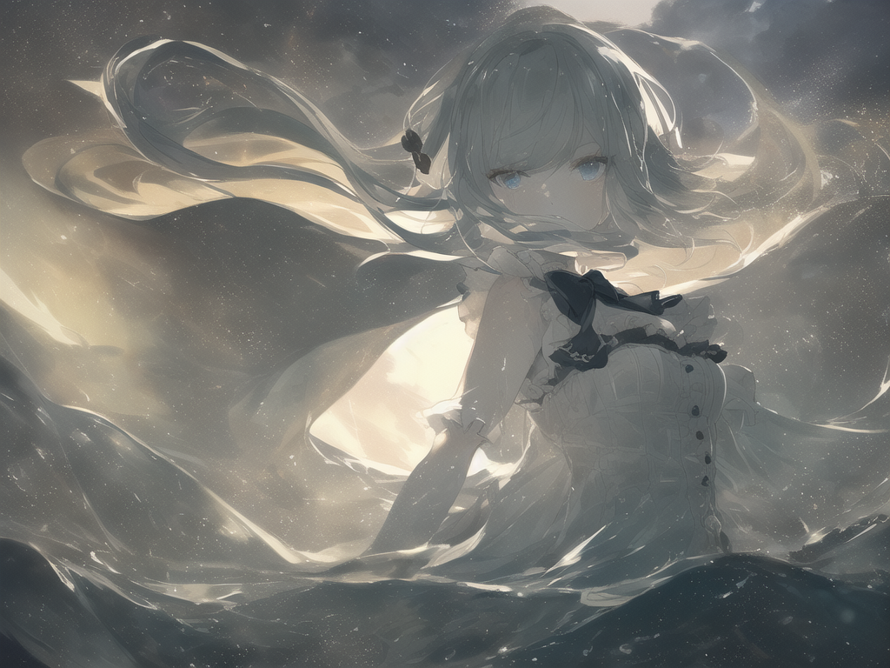
作者：steelplate（QQ 457215551）
其实是在改良隔壁有人遇到问题的tag时发现了一些AI的秘密于是就搞出来了这个。是万恶之源。
- 正面tag：
- ((masterpiece)), (((best quality))), ((ultra-detailed)), ((illustration)), ((disheveled hair)), ((frills)), (1 girl), (solo), dynamic angle, big top sleeves, floating, beautiful detailed sky, on beautiful detailed water, beautiful detailed eyes, overexposure, (fist), expressionless, side blunt bangs, hairs between eyes, ribbons, bowties, buttons, bare shoulders, (((small breast))), detailed wet clothes, blank stare, pleated skirt, flowers
- 反面tag：
- nsfw, owres, bad anatomy, bad hands, text, error, missing fingers, extra digit, fewer digits, cropped, worst quality, low quality, normal quality, jpeg artifacts, signature, watermark, username, blurry,missing fingers,bad hands,missing arms, long neck, Humpbacked
- 参数：
- CFG 5.5, euler_a, step 30

空间法
- 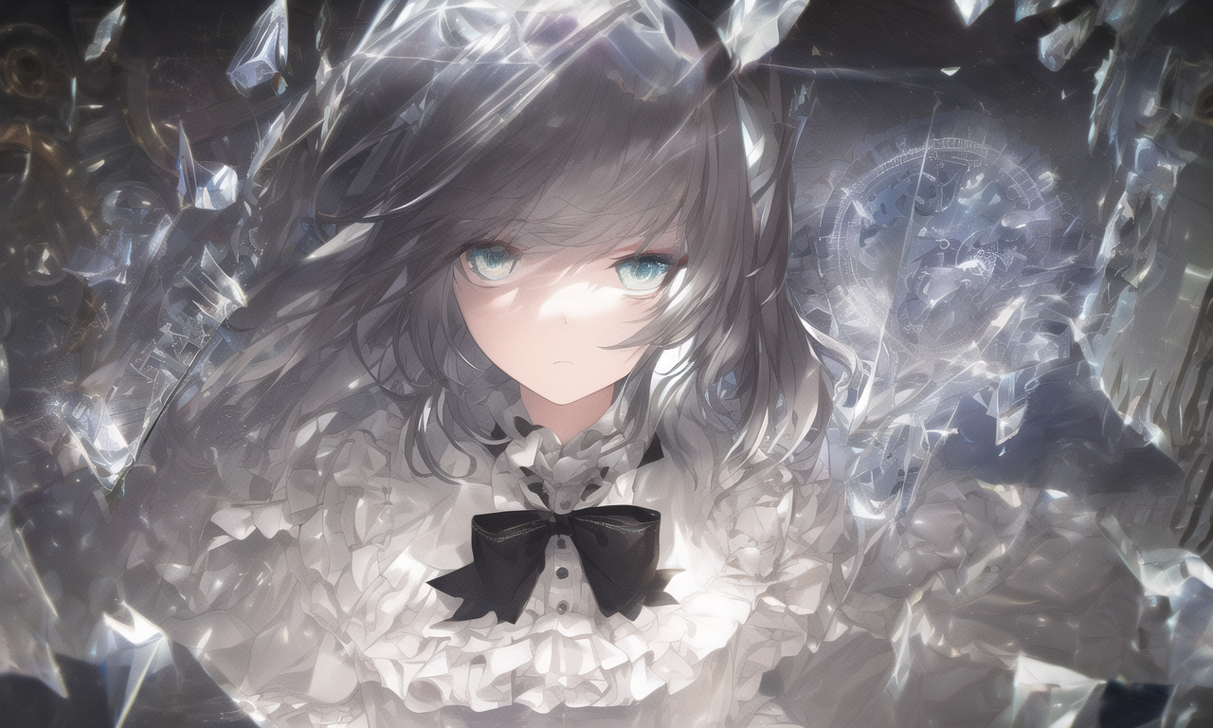
- 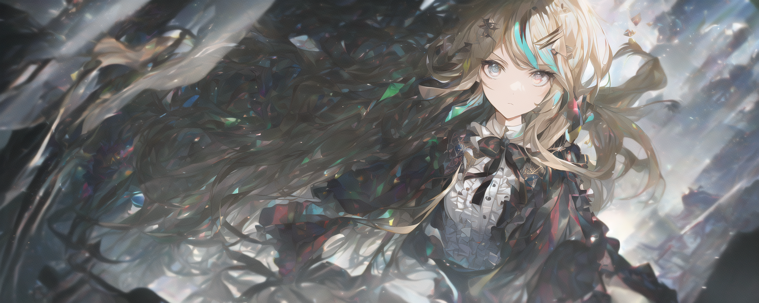
- 作者：steelplate（QQ 457215551）
- 这是一个实验性的项目，旨在以最少的 tag 呈现最强的视觉冲击力。编者认为这是非常具有参考意义的一个 tag，无论是架构还是画面效果。*
- 今天试了试宽画幅，发现效果意外很好。可以去掉 glass strips 以增加钟表出场率。
- *仅代表个人观点
- 正面tag：
- ((illustration)), ((floating hair)), ((chromatic aberration)), ((caustic)), lens flare, dynamic angle, ((portrait)), (1 girl), ((solo)), cute face, ((hidden hands)), asymmetrical bangs, (beautiful detailed eyes), eye shadow, ((huge clocks)), ((glass strips)), (floating glass fragments), ((colorful refraction)), (beautiful detailed sky), ((dark intense shadows)), ((cinematic lighting)), ((overexposure)), (expressionless), blank stare, big top sleeves, ((frills)), hair_ornament, ribbons, bowties, buttons, (((small breast))), pleated skirt, ((sharp focus)), ((masterpiece)), (((best quality))), ((extremely detailed)), colorful, hdr
- 反面tag：
- nsfw, lowres, bad anatomy, bad hands, text error, missing fingers, extra digits, fewer digits, cropped, worst quality, low quality, standard quality, jpeg artifacts, signature, watermark, username, blurry
- 参数：
- cfg 4.5, euler_a, steps 28

冰魔法
- 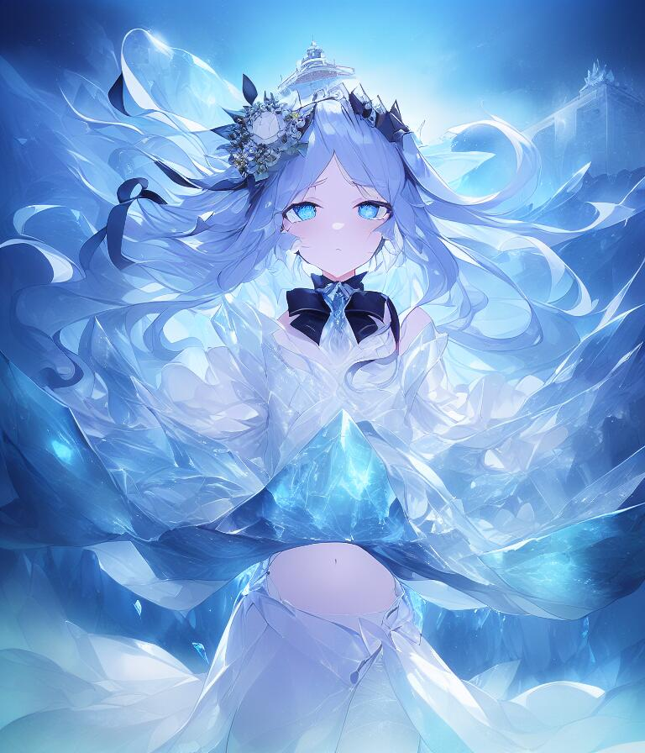
- 作者：ᵐᵃʰⁱʳᵘ（QQ 1273348952）
- 另一个万恶之源。大魔法时代开始的象征之一。
- 正面tag：
(((masterpiece))),best quality, illustration,(beautiful detailed girl),beautiful detailed glow,detailed ice,beautiful detailed water,(beautiful detailed eyes),expressionless,(floating palaces),azure hair,disheveled hair,long bangs, hairs between eyes,(skyblue dress),black ribbon,white bowties,midriff,{{{half closed eyes}}},big forhead,blank stare,flower,large top sleeves
- 反面tag：
- owres,bad anatomy,bad hands,text,error,missing fingers,extra digit,fewer digits,cropped,worst quality,low quality,normal quality,jpeg artifacts,signature,watermark,username,blurry,missing fingers,bad hands,missing arms,large breasts
- 参数：
- Steps: 27, Sampler: Euler a, CFG scale: 7

核爆法
- 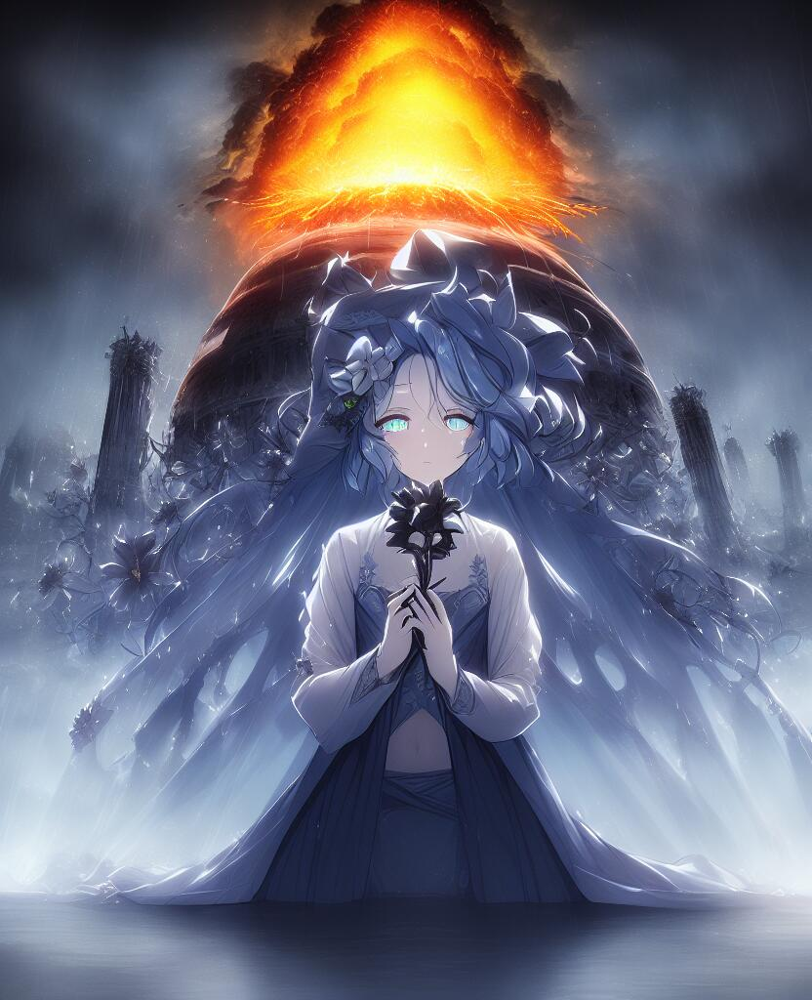
- 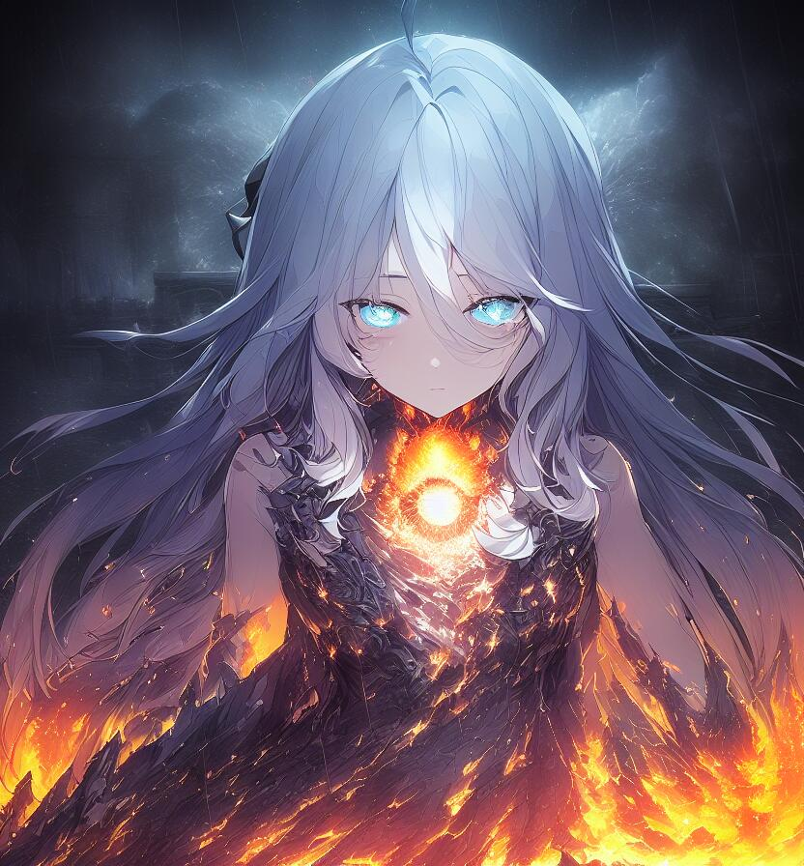
- 作者：ᵐᵃʰⁱʳᵘ（QQ 1273348952）
- 由于核爆法形态过多，所以放两张图
- 正面tag：
- (((masterpiece))),best quality, illustration,(beautiful detailed girl),beautiful detailed glow,((flames of war)),(((nuclear explosion behide))),rain,detailed lighting,detailed water,(beautiful detailed eyes),expressionless,palace,azure hair,disheveled hair,long bangs,hairs between eyes,(whitegrey dress),black ribbon,white bowties,midriff,big forhead,blank stare,flower,long sleeves
- 反面tag：
- Negative prompt: owres,bad anatomy,bad hands,text,error,missing fingers,extra digit,fewer digits,cropped,worst quality,low quality,normal quality,jpeg artifacts,signature,watermark,username,blurry,missing fingers,bad hands,missing arms,large breasts
- 参数：
- Steps: 28, Sampler: Euler a, CFG scale: 7

风魔法
- 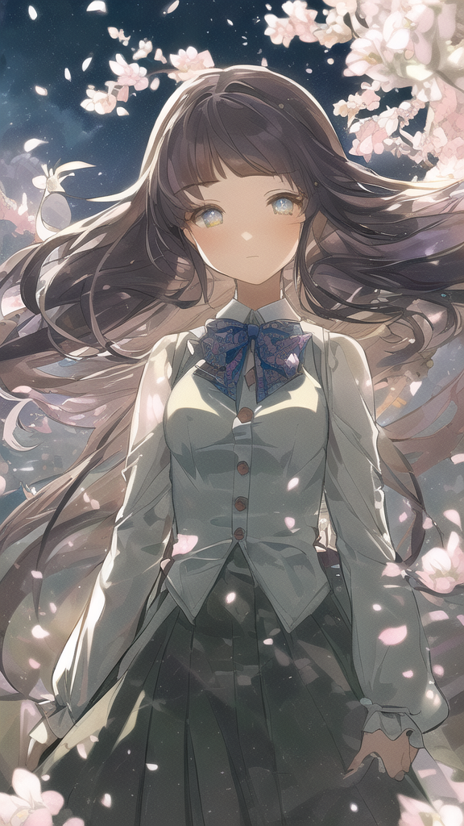
- 作者：老年痴呆的疾风法师（QQ 1431322374）
- “ 别 在 这 立 法 典 ！ ”
- 正面tag：
- (((masterpiece))), (((best quality))), ((ultra-detailed)), (illustration), (1 girl), (solo), ((an extremely delicate and beautiful)), little girl, ((beautiful detailed sky)), beautiful detailed eyes, side blunt bangs, hairs between eyes, ribbons, bowties, buttons, bare shoulders, (small breast), blank stare, pleated skirt, close to viewer, ((breeze)), Flying splashes, Flying petals, wind
- 反面tag：
- nsfw, lowres, bad anatomy, bad hands, text, error, missing fingers, extra digit, fewer digits, cropped, worst quality, low quality, normal quality, jpeg artifacts, signature, watermark, username, blurry, missing fingers, bad hands, missing arms, long neck, Humpbacked, shadow, nude
- 参数：
- CFG: 5.5, euler, step 50

流沙法
- 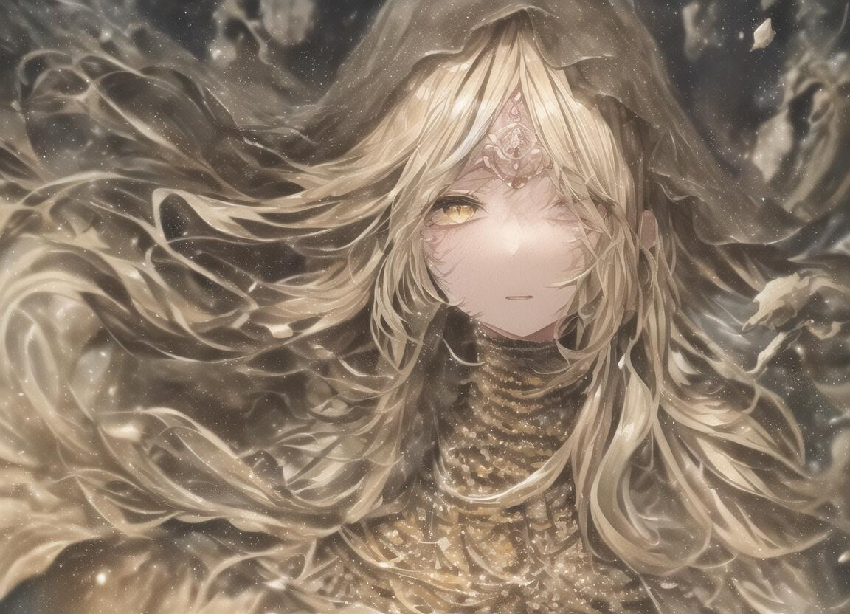
- 作者：咸咸咸鱼（QQ 87153289）
- 正面tag：
- cinematic lighting, ((best quality)),((extremely_detailed_eyes_and_face)),((((ink)))),((illustration)),depth of field,((extremely detailed)),((watercolor)),((anime face)),(((dramatic_angle))),medium_breast,(8k_wallpaper),((bright_eyes)), (looking_at_viewers),(an detailed organdie dress),(((((very_close_to_viewers))))),((sleepy)),((masterpiece)),((((((surrounded_by_heavy_floating_sand_flow_and_floating_sharp_stones)))))),(((((messy_long_hair))))),((((veil)))),focus_on_face,(upper_body),(bare_shoulder),((((1girl)))),(golden_bracelet),(long yarn),((sunset)),lens_flare,light_leaks,((detailed_beautiful_desert_with_cactus)),medium_wind,(detailed_beautiful_sky)
- 反面tag：
- lowres, bad anatomy, bad hands, text, error, missing fingers, extra digit, fewer digits, cropped, worst quality, low quality, normal quality, jpeg artifacts,signature, watermark, username, blurry, artist name,bad feet,nude,skeleton_girl
- 参数：
- CFG 4.5 - 5.5，“其他参数随意”

白骨法
- 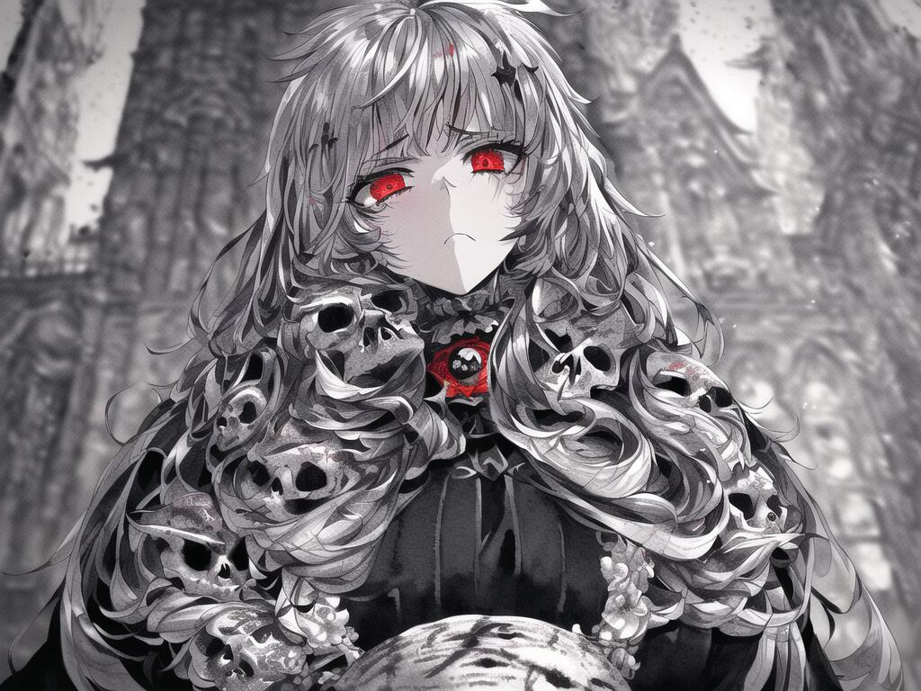
- 作者：咸咸咸鱼（QQ 87153289）
- 目前稳定性较差，不过图的质量还算不错
- 正面tag：
- cinematic lighting, ((best quality)),((single_human_girl)),((((upper_body)))),((extremely_detailed_eyes_and_face)),((church)),((annoyed)),((ink)),((illustration)),depth of field,((frown)),((expression)),((red_eyes)),((((white_hair)))),((extremely detailed)),((watercolor)),((anime face)),(skull_on_dress),(((yokozuwari))),((detailed_skeleton_church)),(((beautiful_detailed_black_gothic_Empire_Waist_Dress))),(((dramatic_angle))),medium_breast,(8k_wallpaper),((bright_eyes)), (looking_at_viewers),((close_to_viewers)),((masterpiece)),(((((messy_long_hair))))),((((1girl)))),lens_flare,light_leaks
- 反面tag：
- lowres, bad anatomy, bad hands, text, error, missing fingers, extra digit, fewer digits, cropped, worst quality, low quality, normal quality, jpeg artifacts,signature, watermark, username, blurry, artist name,bad feet,nude,skeleton_girl
- 参数：
- CFG 6.5，“其他参数随意”

星空法
- 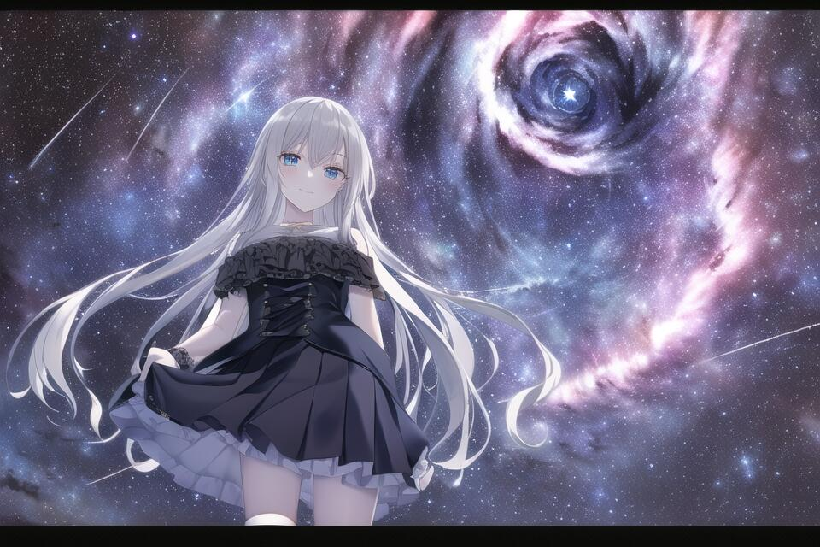
- 作者：symb（QQ 914635985）
- 正面tag：
- ((masterpiece)), (((best quality))), ((ultra-detailed)), ((illustration)), ((disheveled hair)), beautiful detailed eyes, (1girl:1.2),(solo), dynamic angle, dark magician girl,(black kneehighs:1.1),(starry tornado:1.4), starry Nebula, ((frills)), beautiful detailed sky, beautiful detailed eyes,evil smile, expressionless,hairs between eyes, white hair,pleated skirt,((disreveled hair))
- 反面tag：
- lowres, bad anatomy, bad hands, text, error, missing fingers, extra digit, fewer digits, cropped, worst quality, low quality, normal quality, jpeg artifacts, signature, watermark, username, blurry,missing fingers,bad hands,missing arms
- 参数：
- CFG: 6.0, euler_a, steps: 50

机凯种
- 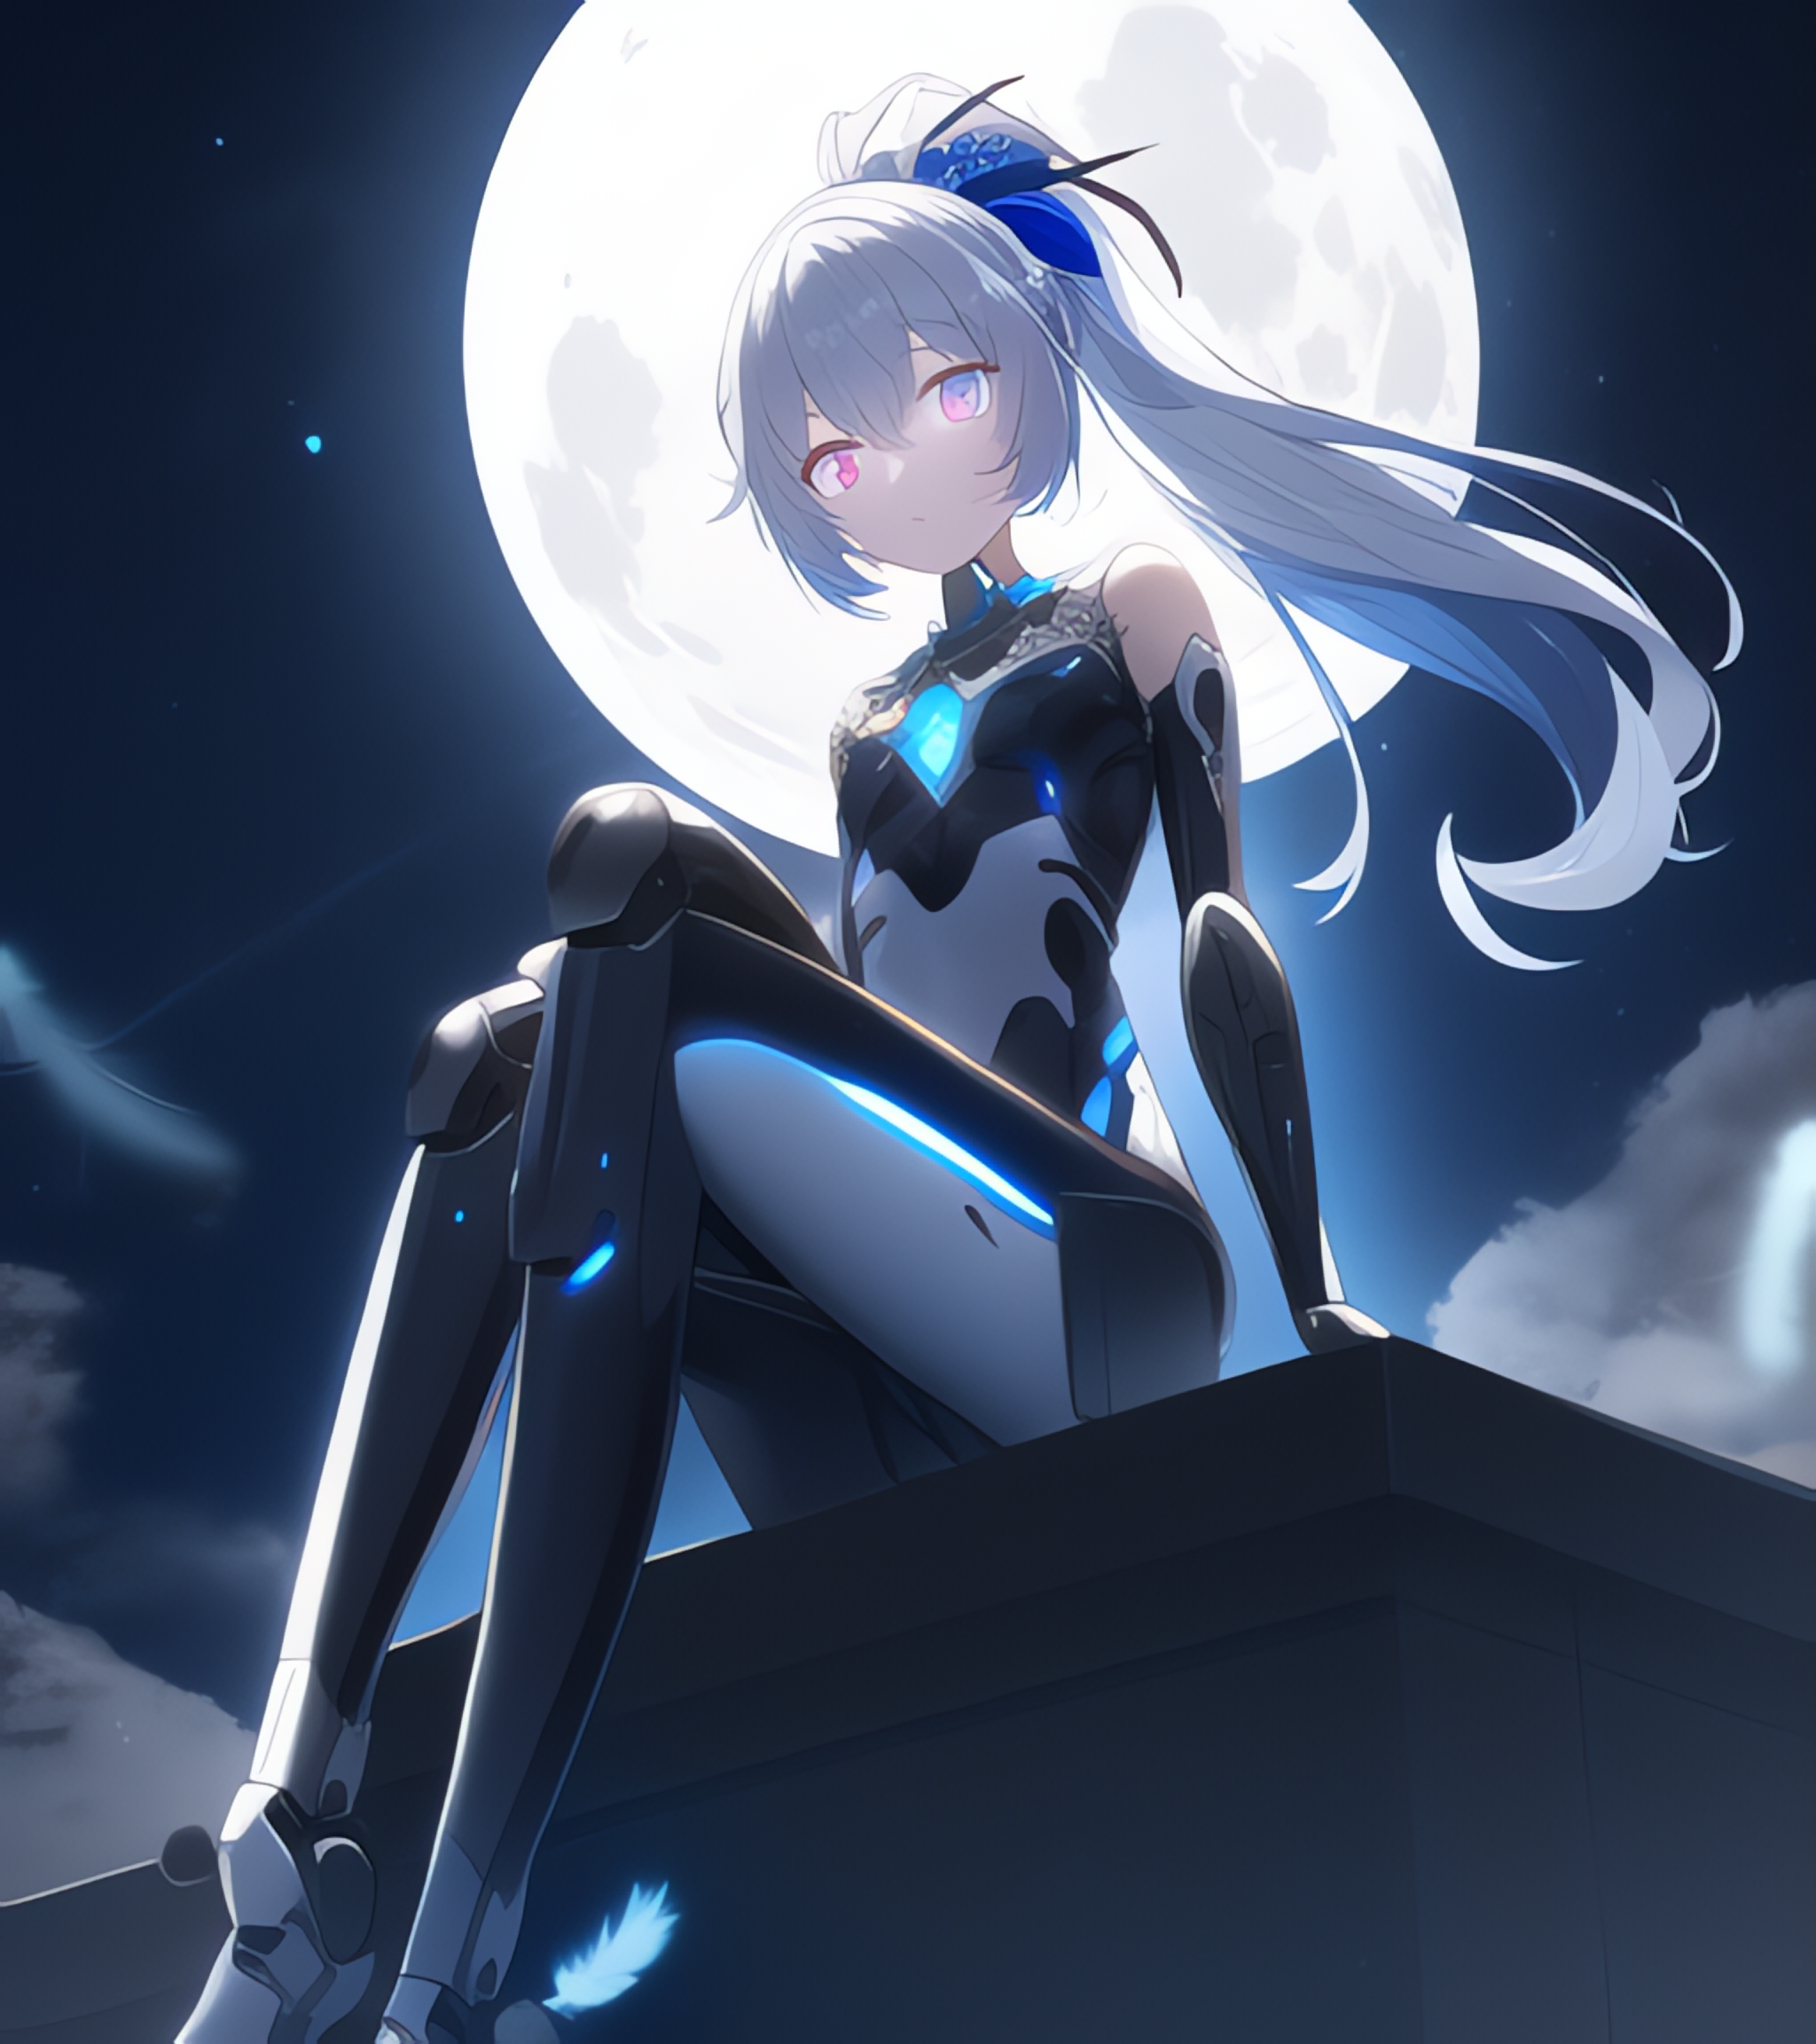
- 作者：孤辰Null（QQ 2659055918）
- “向全体机凯种致以最崇高的敬意！”
- 正面tag：
{{masterpiece}}, flat chestbest quality},{highres},solo,flat_chest,a girl inside the church with white hair and blue pupil surrounded by {many} glowing {feathers} in cold face,detailed face,night with bright colorful lights whith richly layered clouds and clouded moon in the detailed sky,{a lot of glowing particles},high ponytail,mecha clothes,robot girl,cool movement,sliver bodysuit,{filigree},delicate and (intricate) hair,((sliver)) and (broken) body,blue streaked hair,full body,Depth of field, sitting on a {blue star}
- 反面tag：
- lowres, bad anatomy, bad legs,bad hands, text,error, missing fngers,extra digt ,fewer digits,cropped, wort quality ,low quality,normal quality, jpeg,artifacts,signature,watermark, username, blurry, bad feet,artist name,bad anatomy,bad hands,bad body,bad proportions，worst quality,low quality，optical_illusion
- 参数：
- cfg12, euler_a, steps 28

森林冰
- 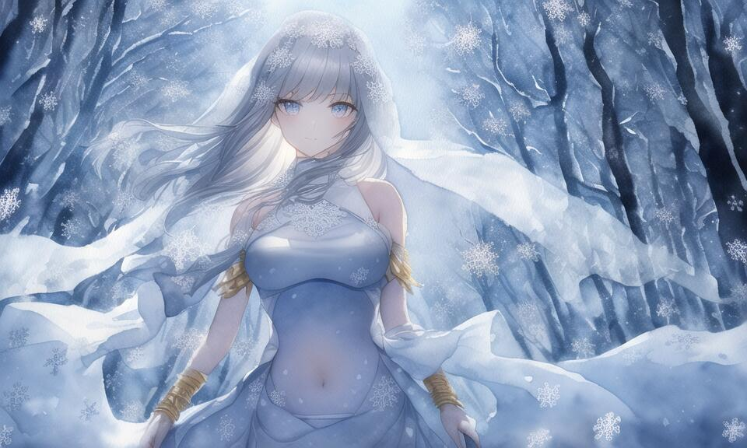
- 作者：大猫（QQ 2438380346）
- 正面tag：
- ((((ink)))，((watercolor))，world masterpiece theater, ((best quality))，depth of field,((illustration))，(1 girl)，anime face，medium_breast,floating，beautiful detailed sky，looking_at_viewers，an detailed organdie dress，very_close_to_viewers，bare_shoulder，golden_bracelet，focus_on_face，messy_long_hair，veil，upper_body，,lens_flare,light_leaks,bare shoulders，detailed_beautiful_Snow Forest_with_Trees， spirit，grey_hair，White clothes，((Snowflakes)),floating sand flow,navel,(beautiful detailed eyes), (8k_wallpaper)
- 反面tag：
- nsfw, owres, bad anatomy, bad hands, text, error, missing fingers, extra digit, fewer digits, cropped, worst quality, low quality, normal quality, jpeg artifacts, signature, watermark, username, blurry,missing fingers,bad hands,missing arms, long neck, Humpbacked，Glasses
- 参数：
- Steps: 30, Sampler: Euler a, CFG scale: 7

幻之时
- 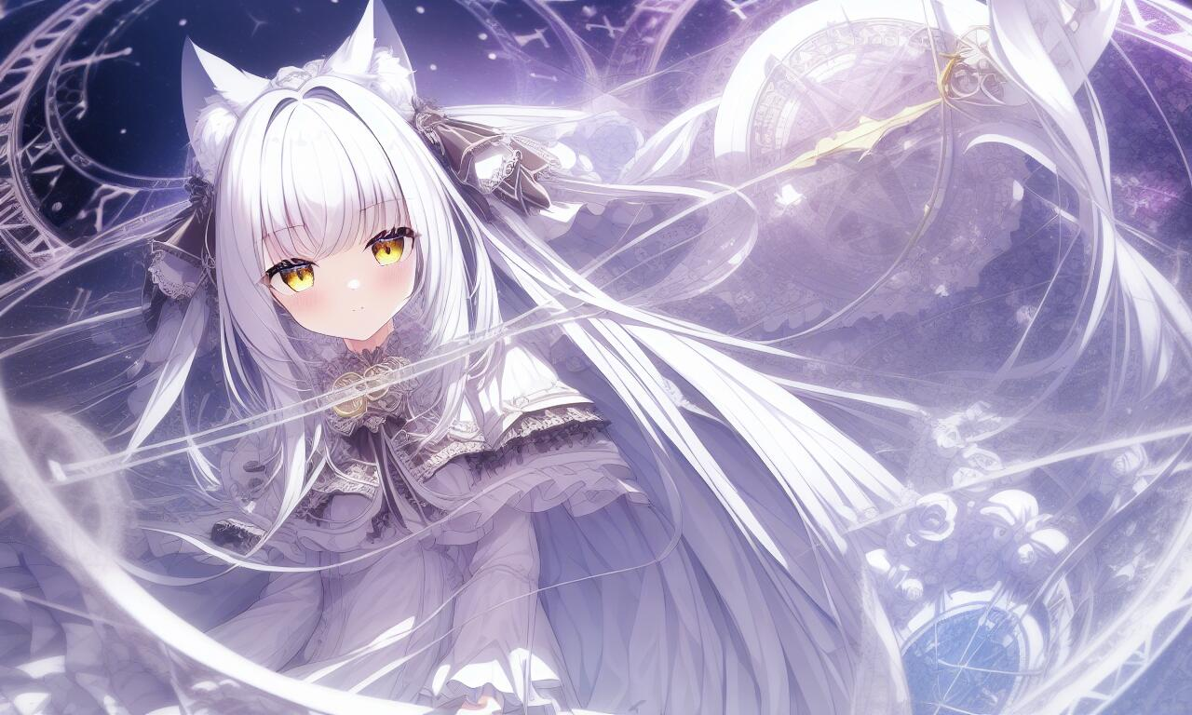
- 作者：天域（QQ 799855103）
- 作者的话
- 正面tag：
{masterpiece},{best quality},{1girl},Amazing,beautiful detailed eyes,finely detail,Depth of field,extremely detailed CG,original, extremely detailed wallpaper,loli,white_hair,magic_circle,cat_ears,long_hair,white_hair/yellow_eyes,wand,pentagram,clock, {masterpiece},{best quality},{1girl},Amazing,beautiful detailed eyes,finely detail,Depth of field,extremely detailed CG,original, extremely detailed wallpaper,loli, white_hair
- 反面tag：
- nsfw, lowres, bad anatomy, bad hands, text, error, missing fingers, extra digit, fewer digits, cropped, worst quality, low quality, normal quality, jpeg artifacts, signature, watermark, username, blurry, nsfw, lowres, bad anatomy, bad hands, text, error, missing fingers, extra digit, fewer digits, cropped, worst quality, low quality, normal quality, jpeg artifacts, signature, watermark, username, blurry
- 参数：
- Steps: 20, Sampler: Euler a, CFG scale: 7

雷男法
- 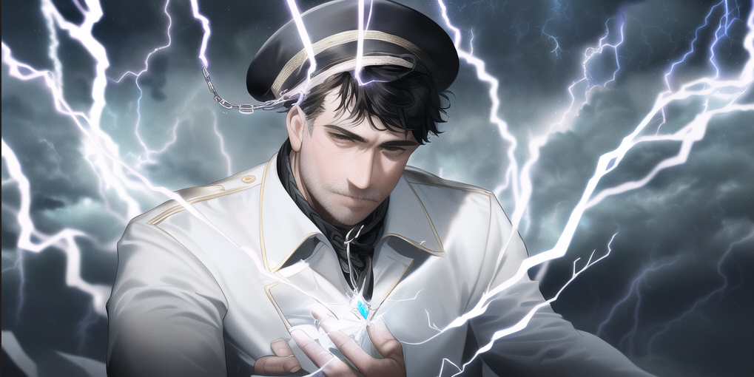
- 作者：幻想紫鲤鱼（QQ 1251966608）
- 正面tag：
- A man with has short black hair, a round hat, no facial features, a high collar coat, Flashes of lightning from the hands,full body,, (((masterpiece))), (((best quality))), ((ultra-detailed)), (illustration), (detailed light),((Expressionless)),, (((masterpiece))), (((best quality))), ((ultra-detailed)), (illustration), (detailed light),((an extremely delicate and beautiful)),((man)),((lightning in hand)),Lightning surrounds men,(((Lightning chain))),Suspended crystal, with lightning inside the crystal,((Suspended colorless crystal))
- 反面tag：
- lowres, bad anatomy, bad hands, text.error,missing fngers,extra digt ,fewer digits,cropped, wort quality .low quality,.normal quality,.jpegartifacts.signature.watermark, username, blurry, bad feet,girl,women
- 参数：
- Steps: 60, Sampler: Euler a, CFG scale: 7.5

圣光法
- 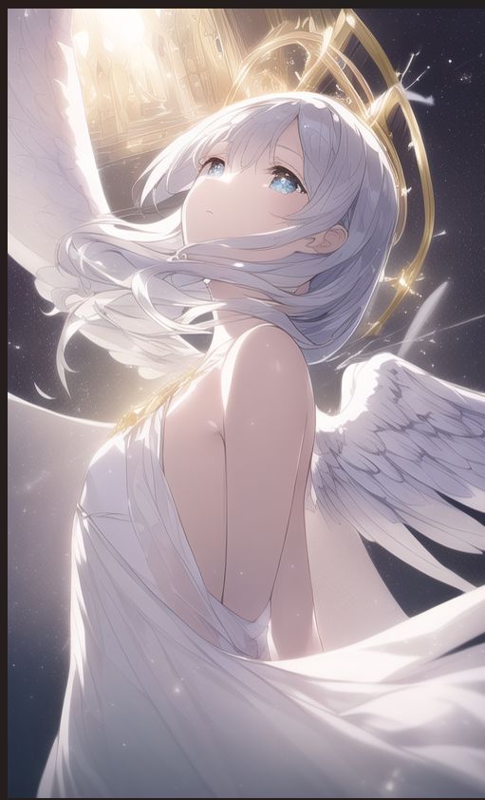
- 作者：幻想紫鲤鱼（QQ 1251966608）
- tips：可加入Facing the lens来固定姿势（AI不会让翅膀永远长在背上。
- 正面tag：
- (((masterpiece))), (((best quality))), ((ultra-detailed)), (illustration), (detailed light),((an extremely delicate and beautiful)),(beautiful detailed eyes), (sunlight),(angel),solo,young girls,dynamic angle,floating, bare_shoulders,looking_at_viewer ,wings ,arms_up,halo,Floating white silk,(Holy Light),just like silver stars imploding we absorb the light of day
- 反面tag：
- owres, bad anatomy, bad hands, text, error, missing fingers, extra digit, fewer digits, cropped, worst quality, low quality, normal quality, jpeg artifacts, signature, watermark, username, blurry,missing fingers,bad hands,missing arms,large breasts
- 参数：
- Steps: 36, Sampler: Euler a, CFG scale: 7

苇名法
- 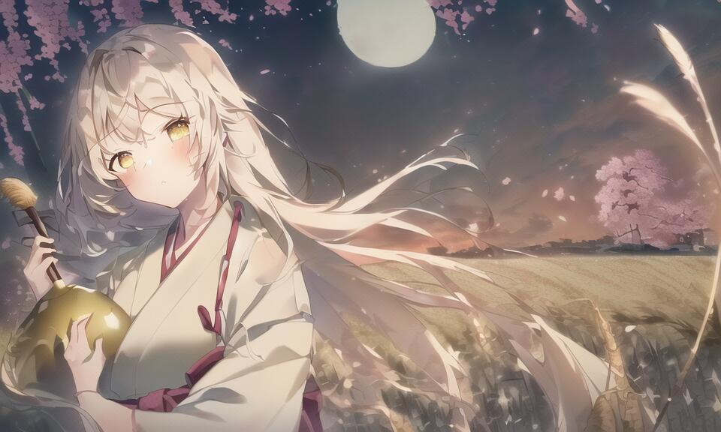
- 咸咸咸鱼（QQ 87153289）
- 正面tag：
- dramatic_shadow,ray_tracing, ((best quality)),(((beautiful_detailed_dark_midnight_sky))),((((yellow_full_moon)))),(holding_wine_gourd),(((((surrounded_by_floating_sakura))))),dramatic_angle,(leaning_on_huge_stone),(((bare_shoulder))),((((very_close_to_viewer)))),(((tispy))),(((sleepy))),((far_from_viewer)),(((extremely_beautiful_detailed_anime_face_and_eyes))),((((((1girl)))))),((((open_hakama)))),((samurai)),(ink),((illustration)),depth of field,(((((beautiful_detailed_pampas_grass_field))))),watercolor,((upper_body)),medium_breast,(bright_eyes),((masterpiece)),((messy_white_long_hair))
- 反面tag：
lowres, bad anatomy, bad hands, text, error, missing fingers, extra digit, fewer digits, cropped, worst quality, low quality, normal quality,
- jpeg artifacts,signature, watermark, username, blurry, artist name,bad feet,nsfw,more_than_1_moon
- 参数：
- cfg: 6.5, 其余默认

自然法
- 
- 作者：半生为夏甗麦至冬（QQ 167894905）
- 背景与人物权重有些不匹配，偶尔会出现只有背景没有人物，但是这个tag主打的就是好看的背景，人物属于调剂品，有时候我都嫌弃这个人物不配和我的背景在一块生成
- 正面tag：
{{{masterpiece}}}, {{best quality, super fine illustration , beautiful and delicate water,The finest grass}}. ((beautiful eyes)),{ very delicate light, perfect and delicate limbs}, {nature, painting, water spray},{{ fine luminescence ,very fine 8K CG wallpaper}},Lavender eyes, pink pupils, whole body, white hair, bright eyes,( (an extremely delicate and beautiful girl)), ((1 girl)), medium bust, dynamic angle, (white dress with gold decoration), (long hair flowing with the wind, beautiful hair ornaments, delicate wet skirt, nsfw, breeze, long bangs between eyes), wrinkled skirt, (staring blankly, lovely big eyes),messy_hair,payot,Lateral braid,(Tulle lace white skirt) Flowers and grass meadow, near the water edge, ((sunset, starry sky in a circle), randomly distributed clouds, (((river))), splashing water, falling petals
- 反面tag：
- multiple breasts, (mutated hands and fingers:1.5 ), (long body :1.3), (mutation, poorly drawn :1.2) ,{Multi foot},{{Multifold}},{Multi fingering}, lowers, bad anatomy, bad hands, missing fingers, pubic hair,extra digit, fewer digits, cropped, worst quality, low quality,colored sclera, monster girl,Black hands, multiple breasts, mutated hands and fingers:1.5 , long body :1.3, (mutation, poorly drawn :1.2) , black-white, bad anatomy, The background is incoherent,more than 2 thighs,huge thighs, huge calf, bad hands, fused hand, missing hand, disappearing arms, disappearing thigh, disappearing calf, disappearing legs,missing fingers, fused fingers, one hand with more than 5 fingers, one hand with less than 5 fingers,bad asshole, fused asshole, missing asshole, bad anus, bad pussy, bad crotch, bad crotch seam, fused anus, fused pussy,((abnormal eye proportion)),(Abnormal hands），( abnormal legs),(abnormal feet abnormal fingers),(sharp face)
- 参数：
- 1280×720， cfg4，euler a，steps：30

冰系改
- 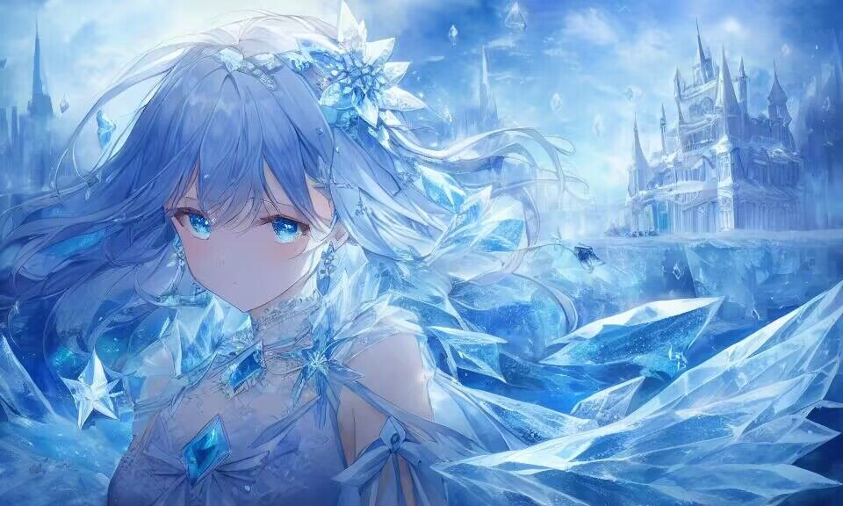
- 作者：离露（QQ 1123820886）
- 更改自群内普通冰法和彩虹术
- 正面tag：
- (((masterpiece))),best quality, illustration,(beautiful detailed girl),beautiful detailed glow,detailed ice,beautiful detailed water,(beautiful detailed eyes),expressionless,beautiful detailed white gloves, (floating palaces:1.2),azure hair,disheveled hair,long bangs, hairs between eyes, (skyblue dress),black ribbon,white bowties,midriff,{{{half closed eyes}}},,big forhead,blank stare,flower,large top sleeves,(((ice crystal texture wings))),{{{{{{{{Iridescence and rainbow hair:2.5}}}}}}},{{{{{{detailed cute anime face}}}}}},{{loli}},{{{{{watercolor_(medium)}}}},(((masterpiece)))
- 反面tag：
- {{{ugly}}},{{{duplicate}}},{{morbid}},{{mutilated}},{{{tranny}}},mutated hands,{{{poorly drawn hands}}},blurry,{{bad anatomy}},{{{bad proportions}}},extra limbs,cloned face,{{{disfigured}}},{{{more than 2 nipples}}},{{{{missing arms}}}},{{{extra legs}}},mutated hands,{{{{{fused fingers}}}}},{{{{{too many fingers}}}}},{{{unclear eyes}}},lowers,bad anatomy,bad hands,text,error,missing fingers,extra digit,fewer digits,cropped,worst quality,low quality,normal quality,jpeg artifacts,signature,watermark,username,blurry,bad
- 参数：
- 默认

融合法
- 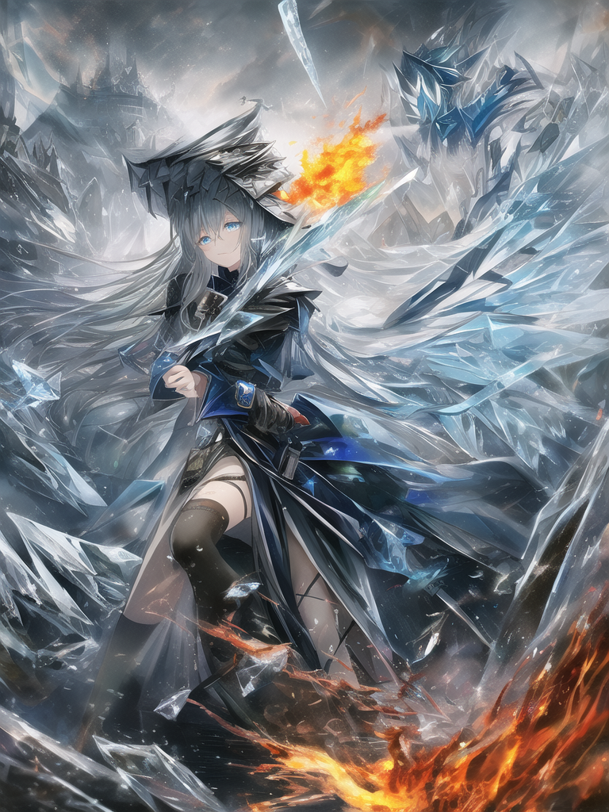
- 作者：antwominy（QQ 863081130）
- 正面tag：
a girl,Phoenix girl,fluffy hair,war,a hell on earth,Beautiful and detailed explosion,Cold machine,Fire in eyes,World War,burning,Metal texture,Exquisite cloth,Metal carving,volume,best quality,normal hands,Metal details,Metal scratch,Metal defects,{{masterpiece}},best quality,official art,4k,best quality,extremely detailed CG unity 8k,illustration,highres,masterpiece,contour deepening,Azur Lane,Girls' Front,Magical，Cloud Map Plan,contour deepening，long-focus，Depth of field，a cloudy sky，Black smoke,smoke of gunpowder, long-focus，Mature, resolute eyes, burning, burning sky, burning hair,Burn oneself in flames, fighting，Covered in blood，complex pattern，battleing，Flying flames，Flame whirlpool，Doomsday Scenes，float，Splashing blood,on the battlefield，Bloody scenes，Good looking flame，Exquisite Flame，Exquisite Blood,photorealistic,Watercolor,colourful, (((masterpiece))),best quality, illustration,beautiful detailed glow,detailed ice,beautiful detailed water,red moon, (magic circle:1,2), (beautiful detailed eyes),expressionless,beautiful detailed white gloves, own hands clasped, (floating palaces:1.1),azure hair,disheveled hair,long bangs, hairs between eyes, dark dress, (dark magician girl:1.1),black kneehighs, black ribbon,white bowties,midriff,{{{half closed eyes}}},,big forhead,blank stare,flower,large top sleeves,, (((masterpiece))),best quality, illustration,(beautiful detailed girl),beautiful detailed glow,detailed ice,beautiful detailed water,(beautiful detailed eyes),expressionless,beautiful detailed white gloves, (floating palaces:1.2),azure hair,disheveled hair,long bangs, hairs between eyes, (skyblue dress),black ribbon,white bowties,midriff,{{{half closed eyes}}},,big forhead,blank stare,flower,large top sleeves,(((ice crystal texture wings)),(((ice and fire melt)))
- 反面tag：
- (((ugly))),(((duplicate))),((morbid)),((mutilated)),(((tranny))),mutated hands,(((poorly drawn hands))),blurry,((bad anatomy)),(((bad proportions))),extra limbs,cloned face,(((disfigured))),(((more than 2 nipples))),((((missing arms)))),(((extra legs))),mutated hands,(((((fused fingers))))),(((((too many fingers))))),(((unclear eyes))),lowers,bad anatomy,bad hands,text,error,missing fingers,extra digit,fewer digits,cropped,worst quality,low quality,normal quality,jpeg artifacts,signature,watermark,username,blurry,bad feet，text font ui,malformed hands,long neck,missing limb,(mutated hand and finger: 1.5),(long body: 1.3),(mutation poorly drawn: 1.2),disfigured,malformed mutated,multiple breasts,futa,yaoi
- 参数：
- Steps: 39, Sampler: Euler, CFG scale: 4.5, 512 x 1024

虹彩法
- 
- 作者：腰刀机（QQ 2489464602）
- 谁不喜欢色彩斑斓的女孩子呢？虹彩系的咒语由于要求极低的scale值，其成图十分不稳定，在经过多次尝试后给出的推荐设置成功率最高
- 已更新。成功率极高。“小心审美疲劳。”
- 再次更新。精简了许多。
- 正面tag：
((extremely detailed CG)),((8k_wallpaper)),(((masterpiece))),((best quality)),watercolor_(medium),((beautiful detailed starry sky)),cinmatic lighting,loli,princess,very long rainbow hair,side view,looking at viewer,full body,frills,(far from viewer),((extremely detailed face)),((an extremely delicate and beautiful girl)),((extremely detailed cute anime face)),((extremely detailed eyes)),(((extremely detailed body))),(ultra detailed),illustration,((bare stomach)),((bare shoulder)),small breast,((sideboob)),((((floating and rainbow hair)))),(((Iridescence and rainbow hair))),(((extremely detailed sailor dress))),((((Iridescence and rainbow dress)))),(Iridescence and rainbow eyes),beautiful detailed hair,beautiful detailed dress,dramatic angle,expressionless,(big top sleeves),frills,blush,(ahoge)
- 反面tag：
lowres,bad anatomy,bad hands,text,error,ugly,duplicate,morbid,boken limb,incorrect limb,fusion finger,lose finger,multiple finger,multiple digit,fusion hand,lose leg,fused leg,multiple leg,bad feet,fewer digits,cropped,worst quality,low quality,normal quality,simple background, jpeg
- 参数：
step28 scale5 k_euler_a 832x512

暗锁法
- 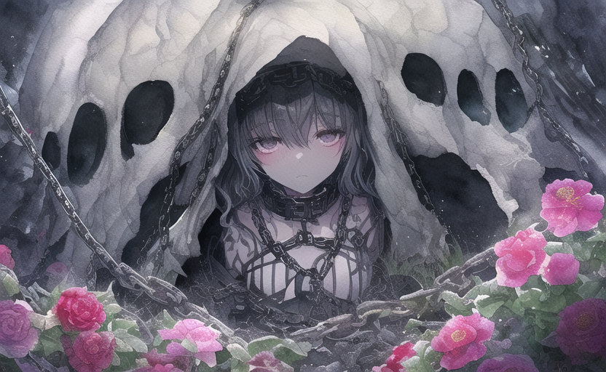
- 作者：腰刀机（QQ 2489464602）
- 正面tag：
- {{{{{masterpiece}}}}},{{{{best quality}}}},illustration,{{beautiful detailed girl}},(((beautiful detailed lighting))),beautiful detailed eyes,(((((disheveled hair))))),{{{beautiful detailed dress}}},midriff,{{female girl}},((off-shoulder jacket)),sailor dress,((((darkside)))),{{{{{bust}}}},{{{{{watercolor_(medium)}}}}},wholeblack bloomer,wet clothes,wet skin,flowers,hollow eyes,hollow night,hollow knight,{{{{{chain}}}}},dark soul,abyssal ship,deep dark,darkness,{{{{female girl}}}}},{{{small breast}}},death garden,{{{{emotionless eyes}}}},{{{cthulhu}}},((((extremely detailed dark clouds)))),{{{{{extremely detailed CG unity 8k wallpaper}}}}},(((extremely detailed face))),(((jitome))),((((dark_persona)))),{{ruins}},{{{{{{beautiful deatailed shadow}}}}}},{{{{chain storm}}}}},{{{{chain ring}}},
- 反面tag：
- {{{ugly}}},{{{duplicate}}},{{morbid}},{{mutilated}},{{{tranny}}},mutated hands,{{{poorly drawn hands}}},blurry,{{bad anatomy}},{{{bad proportions}}},extra limbs,cloned face,{{{disfigured}}},{{{more than 2 nipples}}},{{{{missing arms}}}},{{{extra legs}}},mutated hands,{{{{{fused fingers}}}}},{{{{{too many fingers}}}}},{{{unclear eyes}}},lowers,bad anatomy,bad hands,text,error,missing fingers,extra digit,fewer digits,cropped,worst quality,low quality,normal quality,jpeg artifacts,signature,watermark,username,blurry,bad feet
- 参数：
- step24 scale4.5 k_euler

星冰乐
- 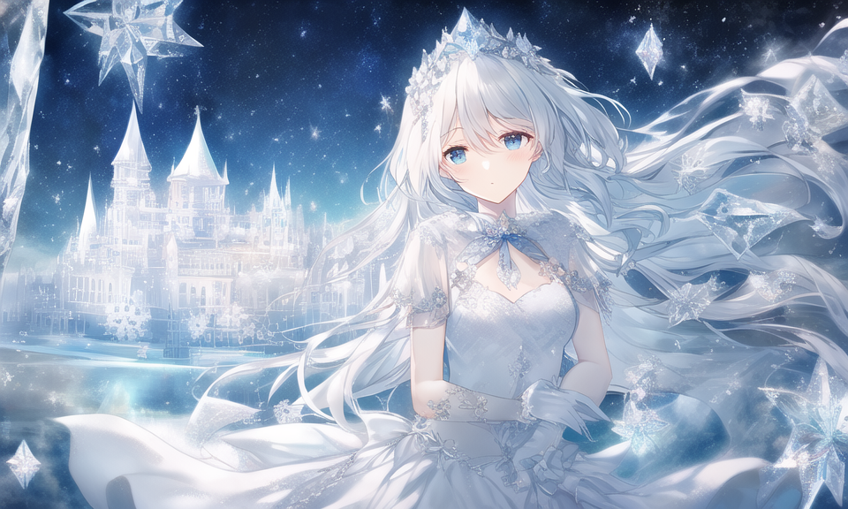
- 作者：symb（QQ 914635985）
- 正面tag：
(((masterpiece))),best quality, illustration,(beautiful detailed girl),beautiful detailed glow,detailed ice,beautiful detailed water,(beautiful detailed eyes),expressionless,beautiful detailed white gloves, (floating palaces:1.3),azure hair,disheveled hair,long bangs, hairs between eyes, (skyblue dress),black ribbon,white bowties,midriff,{{{half closed eyes}}},,big forhead,blank stare,flower,large top sleeves,(((ice crystal texture wings)))
- 反面tag：
- Negative prompt: multiple breasts, (mutated hands and fingers:1.5 ), (long body :1.3), (mutation, poorly drawn :1.2) , black-white, bad anatomy, liquid body, liquid tongue, disfigured, malformed, mutated, anatomical nonsense, text font ui, error, malformed hands, long neck, blurred, lowers, lowres, bad anatomy, bad proportions, bad shadow, uncoordinated body, unnatural body, fused breasts, bad breasts, huge breasts, poorly drawn breasts, extra breasts, liquid breasts, heavy breasts, missing breasts, huge haunch, huge thighs, huge calf, bad hands, fused hand, missing hand, disappearing arms, disappearing thigh, disappearing calf, disappearing legs, fused ears, bad ears, poorly drawn ears, extra ears, liquid ears, heavy ears, missing ears, fused animal ears, bad animal ears, poorly drawn animal ears, extra animal ears, liquid animal ears, heavy animal ears, missing animal ears, text, ui, error, missing fingers, missing limb, fused fingers, one hand with more than 5 fingers, one hand with less than 5 fingers, one hand with more than 5 digit, one hand with less than 5 digit, extra digit, fewer digits, fused digit, missing digit, bad digit, liquid digit, colorful tongue, black tongue, cropped, watermark, username, blurry, JPEG artifacts, signature, 3D, 3D game, 3D game scene, 3D character, malformed feet, extra feet, bad feet, poorly drawn feet, fused feet, missing feet, extra shoes, bad shoes, fused shoes, more than two shoes, poorly drawn shoes, bad gloves, poorly drawn gloves, fused gloves, bad cum, poorly drawn cum, fused cum, bad hairs, poorly drawn hairs, fused hairs, big muscles, ugly, bad face, fused face, poorly drawn face, cloned face, big face, long face, bad eyes, fused eyes poorly drawn eyes, extra eyes, malformed limbs, more than 2 nipples, missing nipples, different nipples, fused nipples, bad nipples, poorly drawn nipples, black nipples, colorful nipples, gross proportions. short arm, (((missing arms))), missing thighs, missing calf, missing legs, mutation, duplicate, morbid, mutilated, poorly drawn hands, more than 1 left hand, more than 1 right hand, deformed, (blurry), disfigured, missing legs, extra arms, extra thighs, more than 2 thighs, extra calf, fused calf, extra legs, bad knee, extra knee, more than 2 legs, bad tails, bad mouth, fused mouth, poorly drawn mouth, bad tongue, tongue within mouth, too long tongue, black tongue, big mouth, cracked mouth, bad mouth, dirty face, dirty teeth, dirty pantie, fused pantie, poorly drawn pantie, fused cloth, poorly drawn cloth, bad pantie, yellow teeth, thick lips, bad cameltoe, colorful cameltoe, bad asshole, poorly drawn asshole, fused asshole, missing asshole, bad anus, bad pussy, bad crotch, bad crotch seam, fused anus, fused pussy, fused anus, fused crotch, poorly drawn crotch, fused seam, poorly drawn anus, poorly drawn pussy, poorly drawn crotch, poorly drawn crotch seam, bad thigh gap, missing thigh gap, fused thigh gap, liquid thigh gap, poorly drawn thigh gap, poorly drawn anus, bad collarbone, fused collarbone, missing collarbone, liquid collarbone, strong girl, obesity, worst quality, low quality, normal quality, liquid tentacles, bad tentacles, poorly drawn tentacles, split tentacles, fused tentacles, missing clit, bad clit, fused clit, colorful clit, black clit, liquid clit, QR code, bar code, censored, safety panties, safety knickers, beard, furry ,pony, pubic hair, mosaic, excrement, faeces, shit, futa, testis
- 参数：
- Steps: 50, Sampler: Euler a, CFG scale: 5.5

火烧云
- 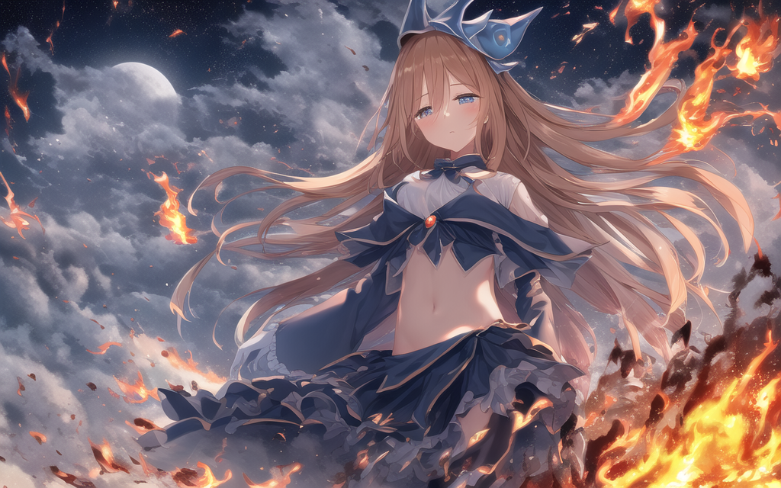
- 作者：symb（QQ 914635985）
- 正面tag：
- (((masterpiece))),best quality, illustration,beautiful detailed glow,(beautiful detailed eyes), (dark magician girl:1.1),big forhead,flower,large top sleeves,Floating ashes, Beautiful and detailed explosion, red moon, fire,Fire cloud, Wings on fire, a cloudy sky, smoke of gunpowder, burning, black dress, (beautiful detailed eyes),expressionless,beautiful detailed white gloves, Dove of peace, (floating cloud:1.2),azure hair,disheveled hair,long bangs, hairs between eyes, black kneehighs, black ribbon,white bowties,midriff,{{{half closed eyes}}},
- 反面tag：
- owres, bad anatomy, bad hands, text, error, missing fingers, extra digit, fewer digits, cropped, worst quality, low quality, normal quality, jpeg artifacts, signature, watermark, username, blurry,missing fingers,bad hands,missing arms
- 参数：
- Steps: 50, Sampler: Euler a, CFG scale: 5.5

城堡法
- 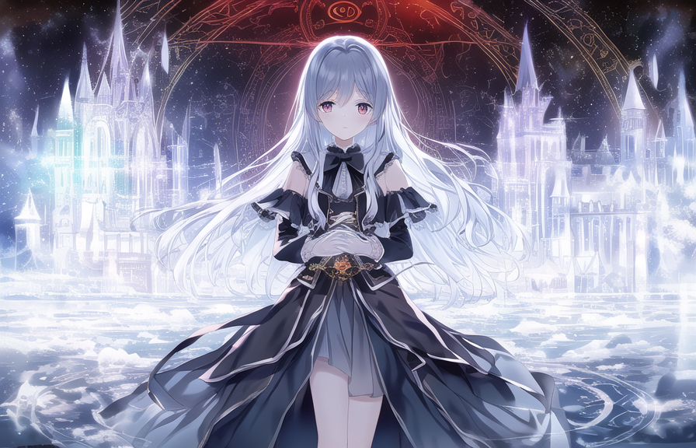
- 
- 作者：symb（QQ 914635985）
- 编者注：这个魔法的作者说因为构图要求提交两张图，因为实在受不了软磨硬泡就同意了...
- 正面tag：
(((masterpiece))),best quality, illustration,beautiful detailed glow,detailed ice,beautiful detailed water,red moon, (magic circle:1,2), (beautiful detailed eyes),expressionless,beautiful detailed white gloves, own hands clasped, (floating palaces:1.1),azure hair,disheveled hair,long bangs, hairs between eyes, dark dress, (dark magician girl:1.1),black kneehighs, black ribbon,white bowties,midriff,{{{half closed eyes}}},,big forhead,blank stare,flower,large top sleeves,
- 反面tag：
- Negative prompt: multiple breasts, (mutated hands and fingers:1.5 ), (long body :1.3), (mutation, poorly drawn :1.2) , black-white, bad anatomy, liquid body, liquid tongue, disfigured, malformed, mutated, anatomical nonsense, text font ui, error, malformed hands, long neck, blurred, lowers, lowres, bad anatomy, bad proportions, bad shadow, uncoordinated body, unnatural body, fused breasts, bad breasts, huge breasts, poorly drawn breasts, extra breasts, liquid breasts, heavy breasts, missing breasts, huge haunch, huge thighs, huge calf, bad hands, fused hand, missing hand, disappearing arms, disappearing thigh, disappearing calf, disappearing legs, fused ears, bad ears, poorly drawn ears, extra ears, liquid ears, heavy ears, missing ears, fused animal ears, bad animal ears, poorly drawn animal ears, extra animal ears, liquid animal ears, heavy animal ears, missing animal ears, text, ui, error, missing fingers, missing limb, fused fingers, one hand with more than 5 fingers, one hand with less than 5 fingers, one hand with more than 5 digit, one hand with less than 5 digit, extra digit, fewer digits, fused digit, missing digit, bad digit, liquid digit, colorful tongue, black tongue, cropped, watermark, username, blurry, JPEG artifacts, signature, 3D, 3D game, 3D game scene, 3D character, malformed feet, extra feet, bad feet, poorly drawn feet, fused feet, missing feet, extra shoes, bad shoes, fused shoes, more than two shoes, poorly drawn shoes, bad gloves, poorly drawn gloves, fused gloves, bad cum, poorly drawn cum, fused cum, bad hairs, poorly drawn hairs, fused hairs, big muscles, ugly, bad face, fused face, poorly drawn face, cloned face, big face, long face, bad eyes, fused eyes poorly drawn eyes, extra eyes, malformed limbs, more than 2 nipples, missing nipples, different nipples, fused nipples, bad nipples, poorly drawn nipples, black nipples, colorful nipples, gross proportions. short arm, (((missing arms))), missing thighs, missing calf, missing legs, mutation, duplicate, morbid, mutilated, poorly drawn hands, more than 1 left hand, more than 1 right hand, deformed, (blurry), disfigured, missing legs, extra arms, extra thighs, more than 2 thighs, extra calf, fused calf, extra legs, bad knee, extra knee, more than 2 legs, bad tails, bad mouth, fused mouth, poorly drawn mouth, bad tongue, tongue within mouth, too long tongue, black tongue, big mouth, cracked mouth, bad mouth, dirty face, dirty teeth, dirty pantie, fused pantie, poorly drawn pantie, fused cloth, poorly drawn cloth, bad pantie, yellow teeth, thick lips, bad cameltoe, colorful cameltoe, bad asshole, poorly drawn asshole, fused asshole, missing asshole, bad anus, bad pussy, bad crotch, bad crotch seam, fused anus, fused pussy, fused anus, fused crotch, poorly drawn crotch, fused seam, poorly drawn anus, poorly drawn pussy, poorly drawn crotch, poorly drawn crotch seam, bad thigh gap, missing thigh gap, fused thigh gap, liquid thigh gap, poorly drawn thigh gap, poorly drawn anus, bad collarbone, fused collarbone, missing collarbone, liquid collarbone, strong girl, obesity, worst quality, low quality, normal quality, liquid tentacles, bad tentacles, poorly drawn tentacles, split tentacles, fused tentacles, missing clit, bad clit, fused clit, colorful clit, black clit, liquid clit, QR code, bar code, censored, safety panties, safety knickers, beard, furry ,pony, pubic hair, mosaic, excrement, faeces, shit, futa, testis
- 参数：
- Steps: 50, Sampler: Euler a, CFG scale: 6

雪月法
- 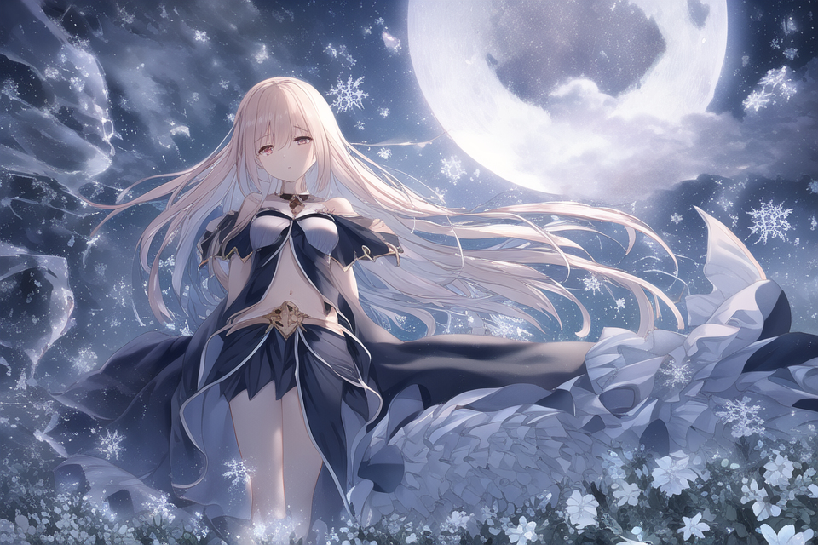
- 作者：symb（QQ 914635985）
- 正面tag：
- hiten_1, (((masterpiece))),best quality, illustration,beautiful detailed glow,detailed ice,beautiful detailed water,red moon,snowflake, (beautiful detailed eyes),expressionless,beautiful detailed white gloves, (floating cloud:1.2),azure hair,disheveled hair,long bangs, hairs between eyes, dark dress, (dark magician girl:1.1),black kneehighs, black ribbon,white bowties,midriff,{{{half closed eyes}}},big forhead,blank stare,flower,large top sleeves,
- 反面tag：
- owres, bad anatomy, bad hands, text, error, missing fingers, extra digit, fewer digits, cropped, worst quality, low quality, normal quality, jpeg artifacts, signature, watermark, username, blurry,missing fingers,bad hands,missing arms
- 参数：
- Steps: 50, Sampler: Euler a, CFG scale: 5.5

结晶法
- 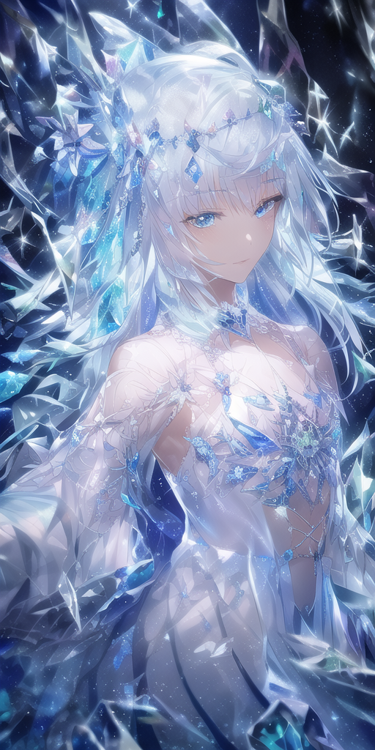
- 作者：Melffy（QQ 775667304）
- 不稳定的玻璃法阵，突出的就是一个闪光瞎眼碎玻璃
正面tag：
- (((crystals texture Hair)))，{{{{{extremely detailed CG}}}}},{{8k_wallpaper}},{{{{Crystalline purple gemstone gloves}}}},((beautiful detailed Glass hair)),((Glass shaped texture hand)),((Crystallize texture body)),Gem body,Hands as clear as jewels,Crystallization of clothes,((crystals texture skin)),sparkle, lens flare, light leaks, Broken glass，{{{{Detailed Glass shaped clothes}}}}， ((masterpiece)), (((best quality))), ((ultra-detailed)), ((illustration)), ((disheveled hair)), ((frills)), (1 girl), (solo), dynamic angle, big top sleeves, floating, beautiful detailed gemstone sky, gemstone sea, beautiful detailed eyes, overexposure, side blunt bangs, hairs between eyes, ribbons, bowties, buttons, bare shoulders, (((small breast))), pleated skirt, crystals texture flowers， ((Detailed crystallized clothing)),(gemstone of body)，solo focus
- 反面tag：
- lowres, bad anatomy, bad hands, text, error, extra digit, fewer digits, cropped, worst quality, low quality, normal quality, jpeg artifacts,signature, watermark, username, blurry, artist name,bad feet,{{{ugly}}},{{{duplicate}}},{{morbid}},{{mutilated}},{{{tranny}}},mutated hands,{{{poorly drawn hands}}},blurry,{{bad anatomy}},{{{bad proportions}}},extra limbs,cloned face,{{{disfigured}}},{{{more than 2 nipples}}},{{{{missing arms}}}},{{{extra legs}}},mutated hands,{{{{{fused fingers}}}}},{{{{{too many fingers}}}}},{{{unclear eyes}}},lowers,bad anatomy,bad hands,text,error,missing fingers,extra digit,fewer digits,cropped,worst quality,low quality,normal quality,jpeg artifacts,signature,watermark,username,blurry,bad
- 参数：
- Steps: 40, Sampler: Euler a, CFG scale: 4.5

黄昏法
- 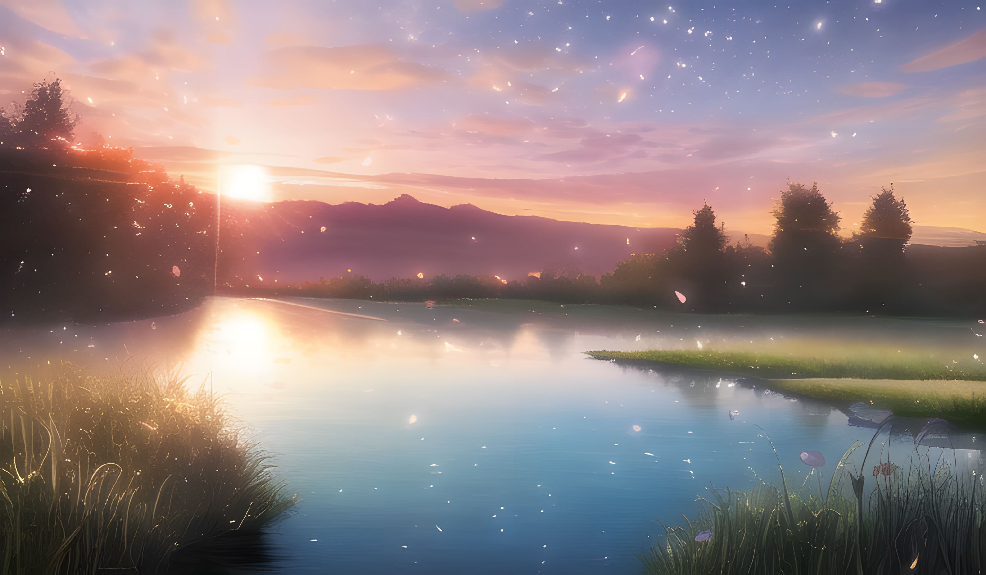
- 作者：半生为夏甗麦至冬（QQ 167894905）
- 作者：我的评价是人不好看，不如风景
- 正面tag：
{{{masterpiece}}}, {{best quality}}, {{super fine illustration}}, {{beautiful and delicate water}}, {{beautiful and detailed eyes}, {very detailed light}, {perfect and delicate limbs}, {nature}, {painting}, {water bloom}, {delicate glow}, {{very fine 8KCG wallpaper}}, lavender eyes, peach pink pupils, whole body, white hair, luminous eyes, an extremely delicate and beautiful girl, (1 girl), medium chest circumference, dynamic angle, (Violet dress with gold decoration), (long hair floating everywhere), (beautiful hair decoration), (delicate wet dress), (nsfw), (breeze), long hair blown up, ((messy hair style)), (long bangs between eyes), wrinkled skirt, Flowers meadow, near the water edge, (((sunset)), (less stars form a circle), randomly distributed clouds, (rivers), (willows with branches falling into the water)
- 反面tag：
- {{{ugly}}},{{{duplicate}}},{{morbid}},{{mutilated}},{{{tranny}}},mutated hands,{{{poorly drawn hands}}},blurry,{{bad anatomy}},{{{bad proportions}}},extra limbs,cloned face,{{{disfigured}}},{{{more than 2 nipples}}},{{{{missing arms}}}},{{{extra legs}}},mutated hands,{{{{{fused fingers}}}}},{{{{{too many fingers}}}}},{{{unclear eyes}}},lowers,bad anatomy,bad hands,text,error,missing fingers,extra digit,fewer digits,cropped,worst quality,low quality,normal quality,jpeg artifacts,signature,watermark,username,blurry,bad feet,{{{{{monotone}}}}}
- 参数：
steps：20，cfg4，1280×768，euler a

森林法
- 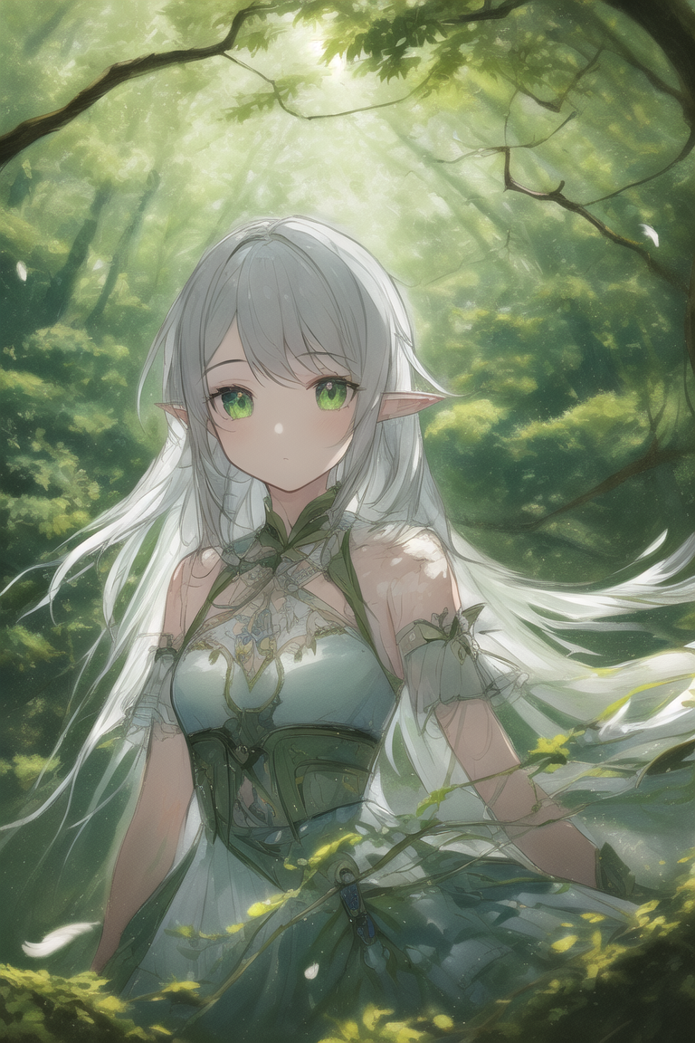
- 作者：Pumpkinhn（QQ 1013239829）
- 正面tag：
(((masterpiece))), (((best quality))), ((ultra-detailed)), (illustration), ((an extremely delicate and beautiful)),dynamic angle,floating, (beautiful detailed eyes), (detailed light) (1girl), loli, small_breasts, floating_hair, glowing eyes, pointy_ears, white hair, green eyes,halter dress, feather, leaves, nature, (sunlight), river, (forest),(painting),(sketch),(bloom)
- 反面tag：
- lowres,bad anatomy,bad hands, text, error, missing fingers,extra digit, fewer digits, cropped, worstquality, low quality, normal quality,jpegartifacts,signature, watermark, username,blurry,bad feet
- 参数：
- step40，scale7

泡泡法
- 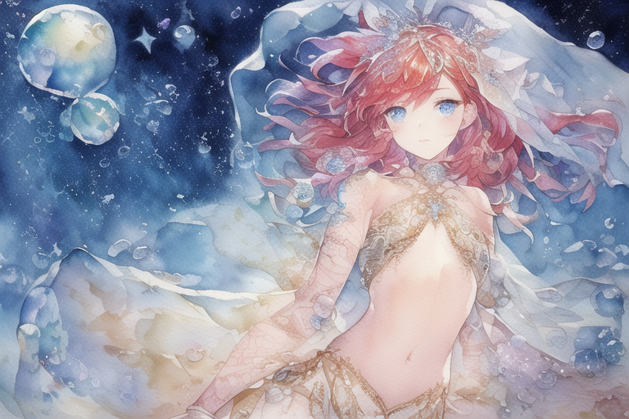
- 作者：Pumpkinhn（QQ 1013239829）
- 正面tag：
(((masterpiece))),(((best quality))),((ultra-detailed)),((illustration)),((an extremely delicate and beautiful)),dynamic angle,floating, (beautiful detailed eyes), (detailed light), (((ink))),depth of field,((watercolor)) 1girl, small breasts, red hair, blue eyes, ((veil)), bare shoulders, navel, (starry sky),(desert),(floating sand flow), (((colorful bubble)))
- 反面tag：
- lowres,bad anatomy,bad hands, text, error, missing fingers,extra digit, fewer digits, cropped, worstquality, low quality, normal quality,jpegartifacts,signature, watermark, username,blurry,bad feet
- 参数：
- Steps: 40, Sampler: Euler a, CFG scale: 5.5

蔷薇法
- 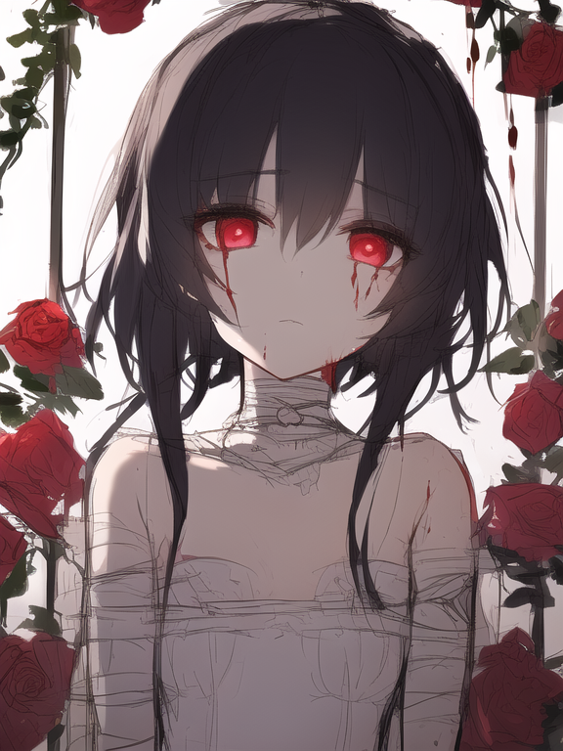
- 作者：Pumpkinhn（QQ 1013239829）
- 正面tag：
(((masterpiece))), (((best quality))), ((ultra-detailed)), (illustration), ((an extremely delicate and beautiful)), beautiful detailed eyes,(detailed light),(beautiful deatailed shadow), 1girl, (loli), (small_breasts), floating_hair, glowing eyes, black hair,red eyes, sad, lolita, bare shoulders, white_dress, ((rose)),(vines), (blood), cage, bandage, red rope, ((sketch)),(painting)
- 反面tag：
- lowres,bad anatomy,bad hands, text, error, missing fingers,extra digit, fewer digits, cropped, worstquality, low quality, normal quality,jpegartifacts,signature, watermark, username,blurry,bad feet
- 参数：
- Steps: 40, Sampler: Euler a, CFG scale: 5.5

月亮法
- 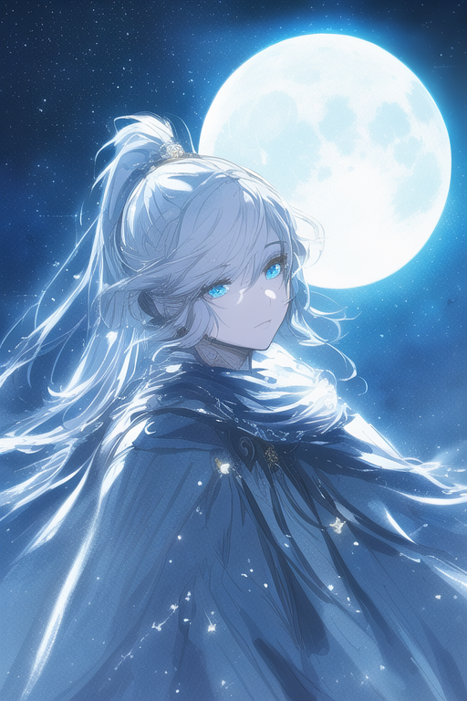
- 作者：Pumpkinhn（QQ 1013239829）
- 正面tag：
(((masterpiece))), (((best quality))), ((ultra-detailed)), (illustration), ((an extremely delicate and beautiful)),cinematic angle,floating, (beautiful detailed eyes), (detailed light),cinematic lighting, beautifully detailed sky,
(1girl), white hair, blue eyes, (high ponytail), cloak, glowing eyes,
((moon)),(moonlight), starry sky, (lighting particle), fog, snow
- (painting),(sketch),(bloom)
- 反面tag：
lowres,bad anatomy,bad hands, text, error, missing fingers,extra digit, fewer digits, cropped, worstquality, low quality, normal quality,jpegartifacts,signature, watermark, username,blurry,bad feet
- 参数：
- Steps: 40, Sampler: Euler a, CFG scale: 5.5

森火法
- 
- 作者：大猫（QQ 2438380346）
- 正面tag：
- ((((ink))))，((watercolor))，((best quality))，(spirit),((illustration))，(((1 girl)))，(beautiful detailed eyes)，world masterpiece theater,depth of field，(Burning forest)，spark，anime face，Black gauze skirt，(red_hair)，blue_eyes，focus_on_face,medium_breasts，(((((messy_long_hair)))))，Bare shoulder，very_close_to_viewers，veil，light_leaks，Burning sky，navel，((bustier))，flame，Red Gem Necklace，Rainbow in the sky，Flames burning around,A burning church，(((Fire butterflys )))，(Flying sparks)
- 反面tag：
- Negative prompt: nsfw, owres, bad anatomy, bad hands, text, error, missing fingers, extra digit, fewer digits, cropped, worst quality, low quality, normal quality, jpeg artifacts, signature, watermark, username, blurry,missing fingers,bad hands,missing arms, long neck, Humpbacked，Glasses
- 参数：
- Steps: 30, Sampler: Euler a, CFG scale: 5.5

废土法
- 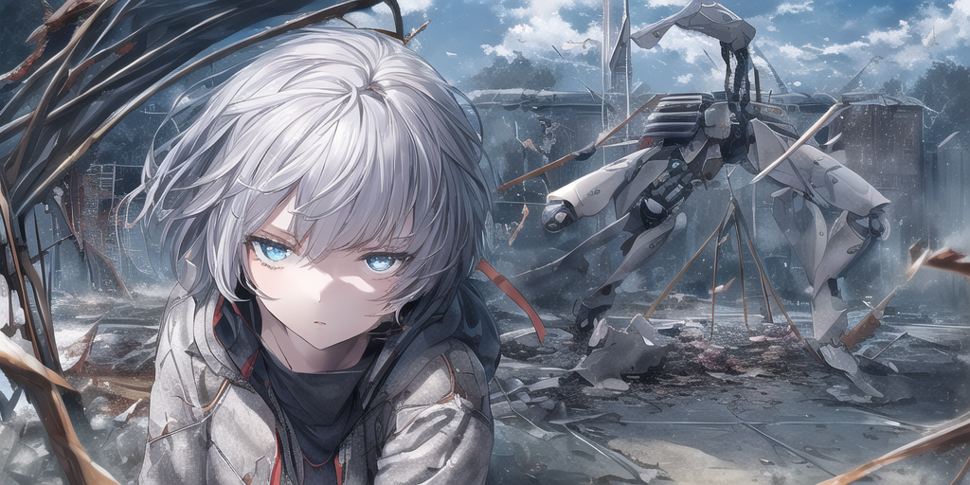
- 作者：易者（QQ 1608090027）
- 谁不喜欢废土上坚强生存的妹子呢？
- 正面tag：
(((masterpiece))), best quality, illustration,(((1girl))),((cute anime face)),(beautiful detailed girl),expressionless,cold attitude, red pupils, short hair, white hair,(((beautiful detailed eyes))),jacket,cracked floor,damaged classroom,Tables and chairs in disarray,The residual eaves DuanBi,beautiful sky,cumulus,mouldy,floating,wind,Dead end machine,(broken robot),(Mechanical girl)
- 反面tag：
- lowres, bad anatomy, bad hands, text, error, missing fingers, extra digit, fewer digits, cropped, worst quality, low quality, normal quality, jpeg artifacts, signature, watermark, username, blurrylowres, bad anatomy, bad hands, text, error, missing fingers, extra digit, fewer digits, cropped, worst quality, low quality, normal quality, jpeg artifacts, signature, watermark, username, blurry,tidy classroom,Neat tables and chairs
- 参数：
- Steps: 45, Sampler: Euler a, CFG scale: 5.5

机娘水
- 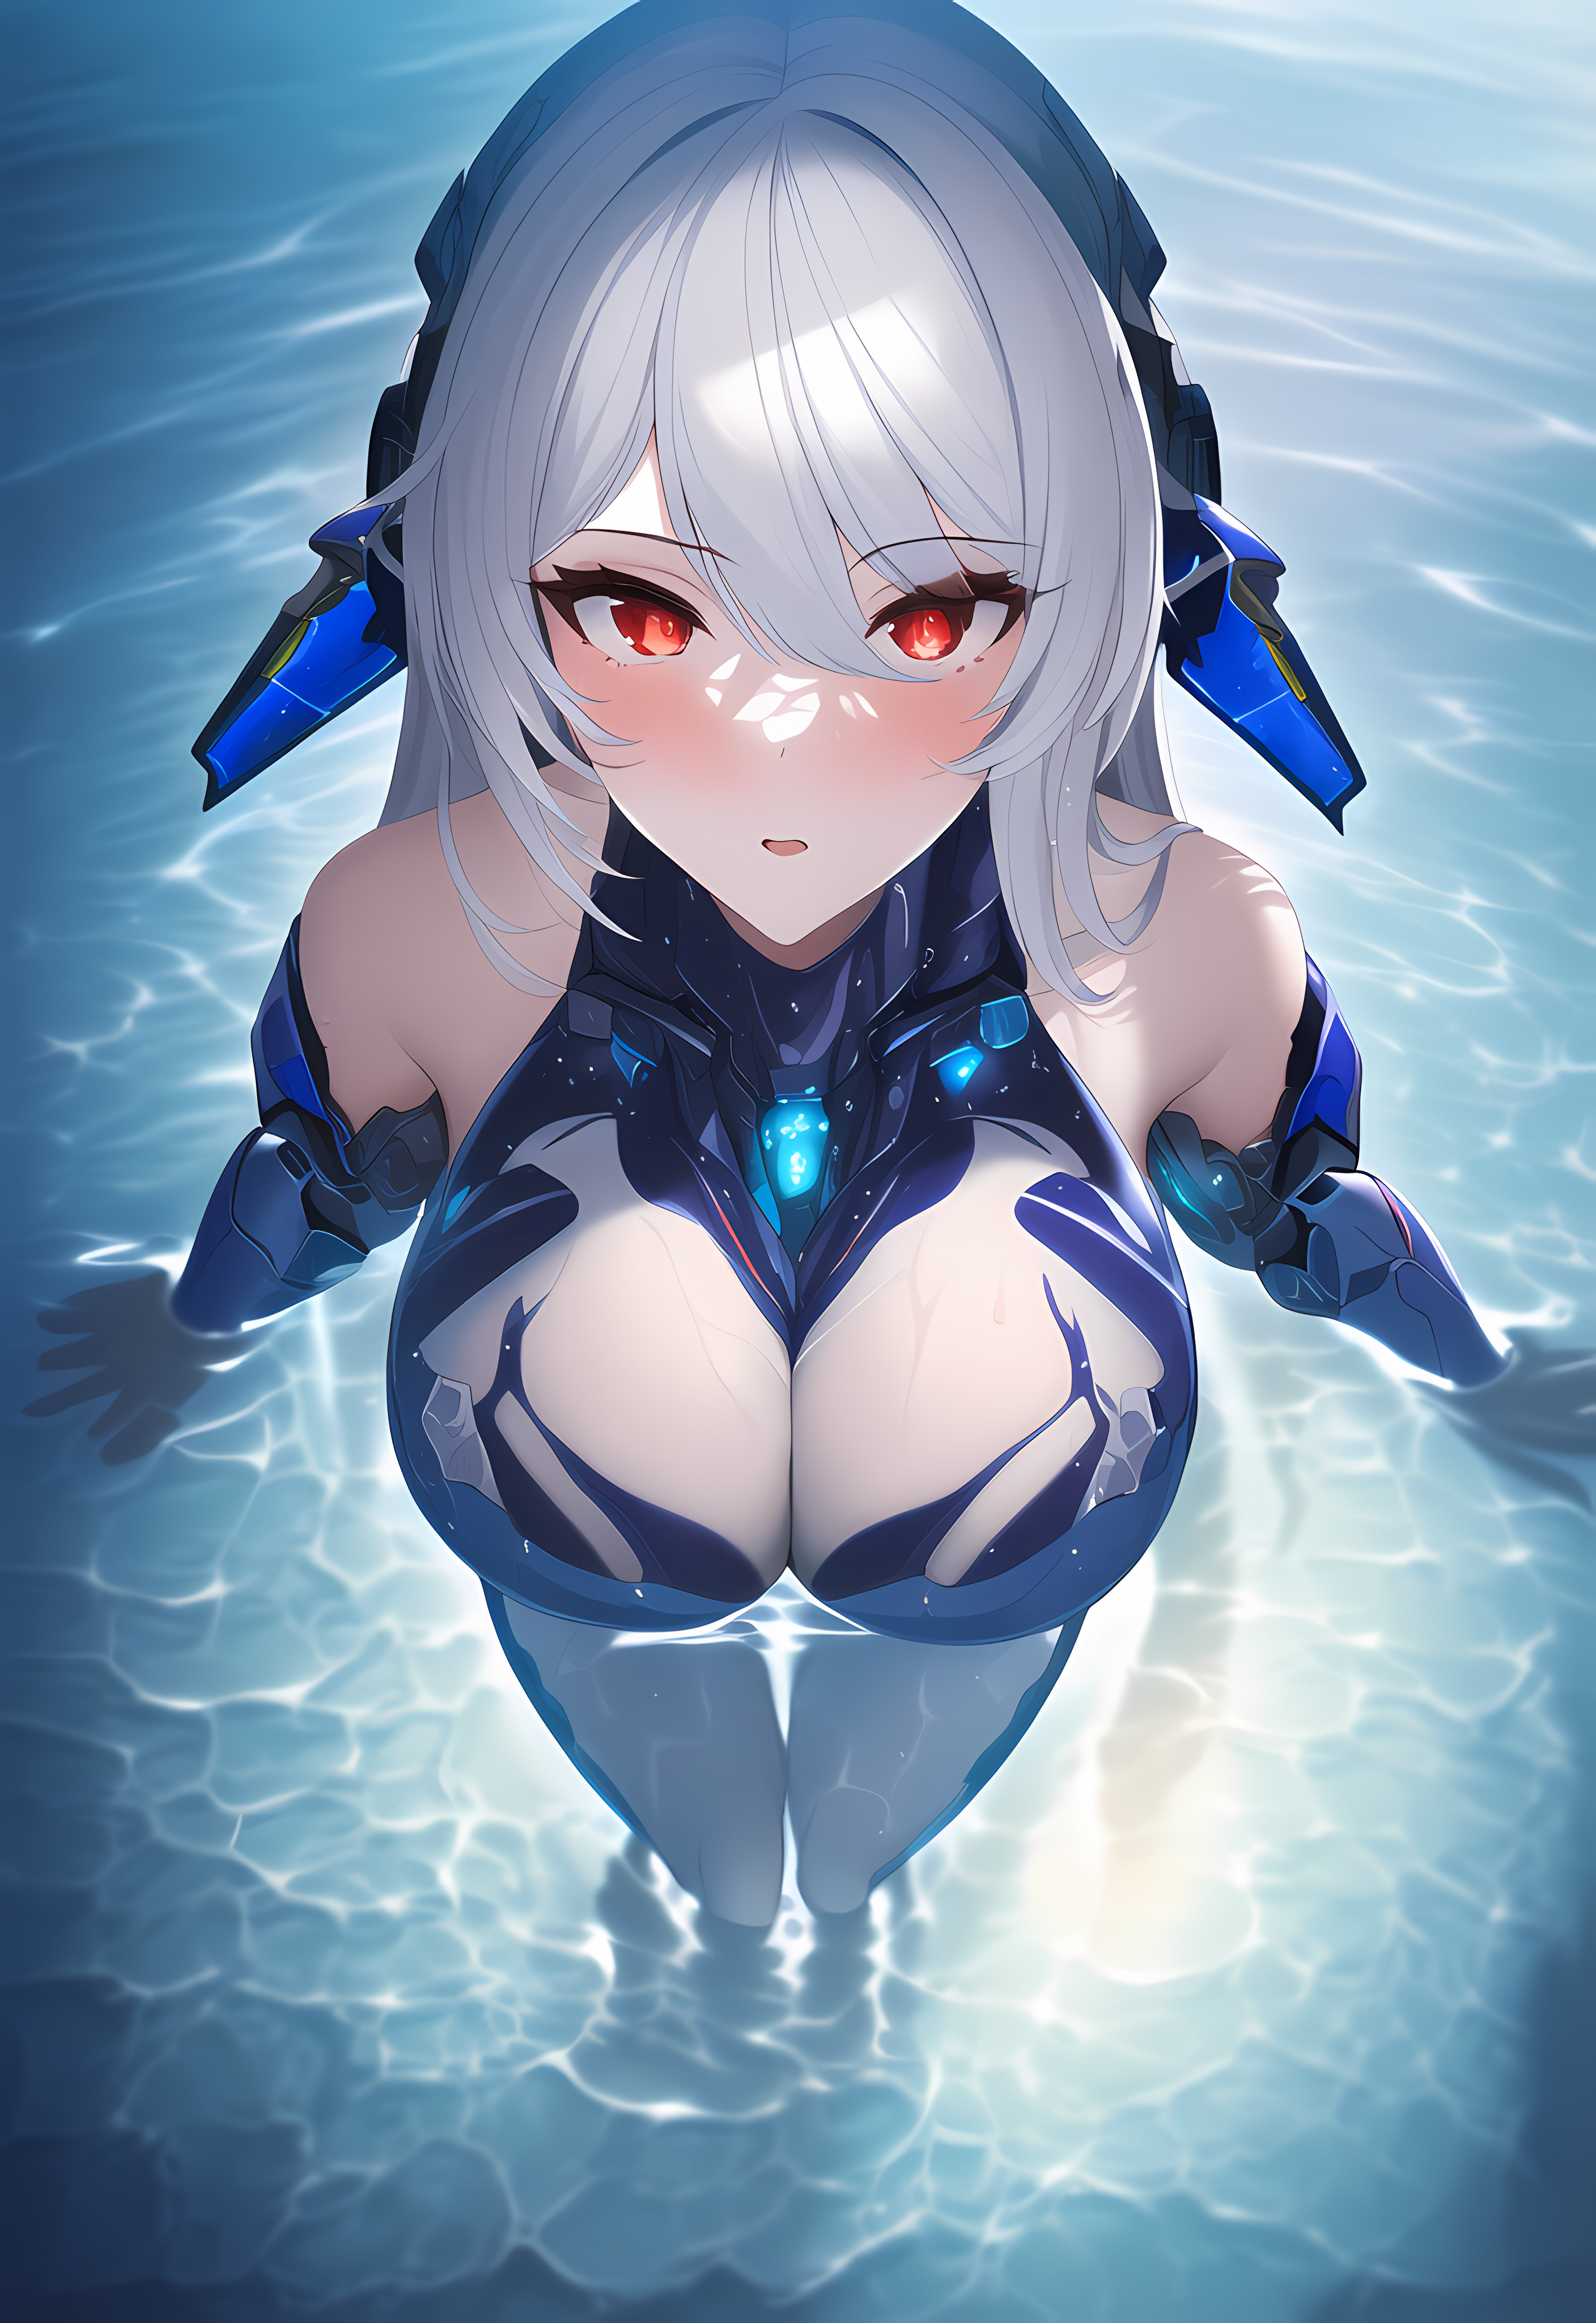
- 作者：某驾校校长（QQ 3062945846）
- 编者注：别太过分嗷你小子
- 正面tag：
- (masterpiece), best quality,{full body},((1 girl)),((beauty detailed eye)),{mecha,huge_filesize},(bare shoulders),science fiction,highly detailed,illustration,extremely detailed CG unity wallpaper,submerge,cinematic lighting,dramatic angle,{{beautiful face}},posing,caustics,fine water surface,,Mechanical wing,Metal wings,Mecha wing,{mecha clothes},robot girl,beautiful detailed face,
- 反面tag：
- bad anatomy, bad hands, text, error, missing fingers, extra digit, fewer digits, cropped, worst quality, low quality, normal quality, jpeg artifacts, signature, watermark, username, blurry,missing fingers,bad hands,missing arms, long neck, Humpbacked
- 参数：
- Steps: 38, Sampler: Euler a, CFG scale: 12

黄金法
- 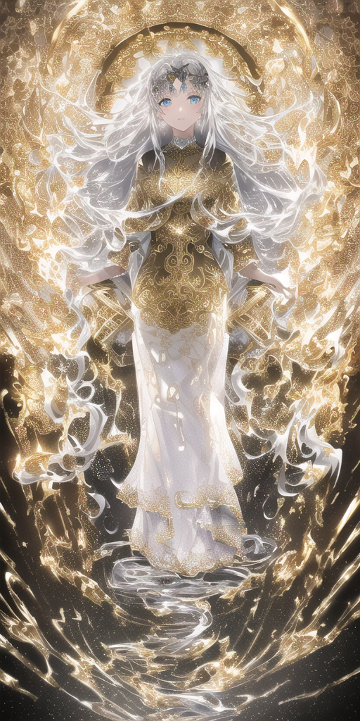
- 作者：antwominy（QQ 863081130）
- 正面tag：
- masterpiece, best quality, best quality, Amazing, beautiful detailed eyes,((1girl)), finely detailed, Depth of field, extremely detailed CG unity 8k wallpaper, full body,(other Minato aqua), (((a girl wears Clothes with a silver texture)))，((Extremely gorgeous metal style))，((Metal crown with ornate stripes))，((((Various metals background))))，Sputtered molten iron,(floating hair),((Hair like melted metal)),(((detailed face))), (((detailed eyes))),(((Clothes made of silver))),(((Clothes with gold lace))),((full body)),((((flowing gold and silver)))),(((((everything flowing and melt))))),(((((flowing iron))))),(((((flowing silver))))),((((lace flowing and melt))))
- 反面tag：
- (((ugly))),(((duplicate))),((morbid)),((mutilated)),(((tranny))),mutated hands,(((poorly drawn hands))),blurry,((bad anatomy)),(((bad proportions))),extra limbs, cloned face,(((disfigured))),(((more than 2 nipples))),((((missing arms)))),(((extra legs))),mutated hands,(((((fused fingers))))),(((((too many fingers))))),(((unclear eyes))),lowers, bad anatomy, bad hands,text,error, missing fingers, extra digit, fewer digits, cropped, worst quality, low quality, normal quality,jpeg artifacts, signature, watermark, username, blurry, bad feet, text font ui,malformed hands, long neck, missing limb,(mutated hand and finger: 1.5),(long body: 1.3),(mutation poorly drawn: 1.2), disfigured, malformed mutated, multiple breasts, futa, yaoi
- 参数：
- Steps: 30, Sampler: Euler, CFG scale: 7

死灵法
- 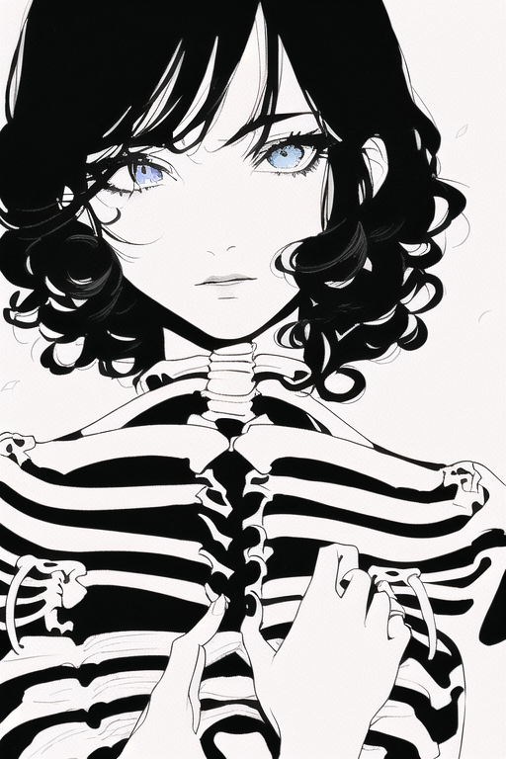
- 作者：Phoebe（QQ 3101516445）
- 作者的话：我是医学生。
- 正面tag：
- cinematic lighting, ((best quality)),((single_human_girl)),((((upper_body)))),((extremely_detailed_eyes_and_face)),ink,(((bone))), (((ribs))), one girl, a young girl, upper body, rose, black hair, blue eyes,curly hair,greyscale,no shadow, simple background, bright skin,Cherry blossoms
- 反面tag：
- multiple breasts, (mutated hands and fingers:1.5 ), (long body :1.3), (mutation, poorly drawn :1.2) , black-white, bad anatomy, liquid body, liquid tongue, disfigured, malformed, mutated, anatomical nonsense, text font ui, error, malformed hands, long neck, blurred, lowers, lowres, bad anatomy, bad proportions, bad shadow, uncoordinated body, unnatural body, fused breasts, bad breasts, huge breasts, poorly drawn breasts, extra breasts, liquid breasts, heavy breasts, missing breasts, huge haunch, huge thighs, huge calf, bad hands, fused hand, missing hand, disappearing arms, disappearing thigh, disappearing calf, disappearing legs, fused ears, bad ears, poorly drawn ears, extra ears, liquid ears, heavy ears, missing ears, fused animal ears, bad animal ears, poorly drawn animal ears, extra animal ears, liquid animal ears, heavy animal ears, missing animal ears, text, ui, error, missing fingers, missing limb, fused fingers, one hand with more than 5 fingers, one hand with less than 5 fingers, one hand with more than 5 digit, one hand with less than 5 digit, extra digit, fewer digits, fused digit, missing digit, bad digit, liquid digit, colorful tongue, black tongue, cropped, watermark, username, blurry, JPEG artifacts, signature, 3D, 3D game, 3D game scene, 3D character, malformed feet, extra feet, bad feet, poorly drawn feet, fused feet, missing feet, extra shoes, bad shoes, fused shoes, more than two shoes, poorly drawn shoes, bad gloves, poorly drawn gloves, fused gloves, bad cum, poorly drawn cum, fused cum, bad hairs, poorly drawn hairs, fused hairs, big muscles, ugly, bad face, fused face, poorly drawn face, cloned face, big face, long face, bad eyes, fused eyes poorly drawn eyes, extra eyes, malformed limbs, more than 2 nipples,missing nipples, different nipples, fused nipples, bad nipples, poorly drawn nipples, black nipples, colorful nipples, gross proportions. short arm, (((missing arms))), missing thighs, missing calf, missing legs, mutation, duplicate, morbid, mutilated, poorly drawn hands, more than 1 left hand, more than 1 right hand, deformed, (blurry), disfigured, missing legs, extra arms, extra thighs, more than 2 thighs, extra calf, fused calf, extra legs, bad knee, extra knee, more than 2 legs, bad tails, bad mouth, fused mouth, poorly drawn mouth, bad tongue, tongue within mouth, too long tongue, black tongue, big mouth, cracked mouth, bad mouth, dirty face, dirty teeth, dirty pantie, fused pantie, poorly drawn pantie, fused cloth, poorly drawn cloth, bad pantie, yellow teeth, thick lips, bad cameltoe, colorful cameltoe, bad asshole, poorly drawn asshole, fused asshole, missing asshole, bad anus, bad pussy, bad crotch, bad crotch seam, fused anus, fused pussy, fused anus, fused crotch, poorly drawn crotch, fused seam, poorly drawn anus, poorly drawn pussy, poorly drawn crotch, poorly drawn crotch seam, bad thigh gap, missing thigh gap, fused thigh gap, liquid thigh gap, poorly drawn thigh gap, poorly drawn anus, bad collarbone, fused collarbone, missing collarbone, liquid collarbone, strong girl, obesity, worst quality, low quality, normal quality, liquid tentacles, bad tentacles, poorly drawn tentacles, split tentacles, fused tentacles, missing clit, bad clit, fused clit, colorful clit, black clit, liquid clit, QR code, bar code, censored, safety panties, safety knickers, beard, furry ,pony, pubic hair, mosaic, excrement, faeces, shit, futa, testis
- 参数：
- Steps: 50, Sampler: Euler a, CFG scale: 12

水晶法
- 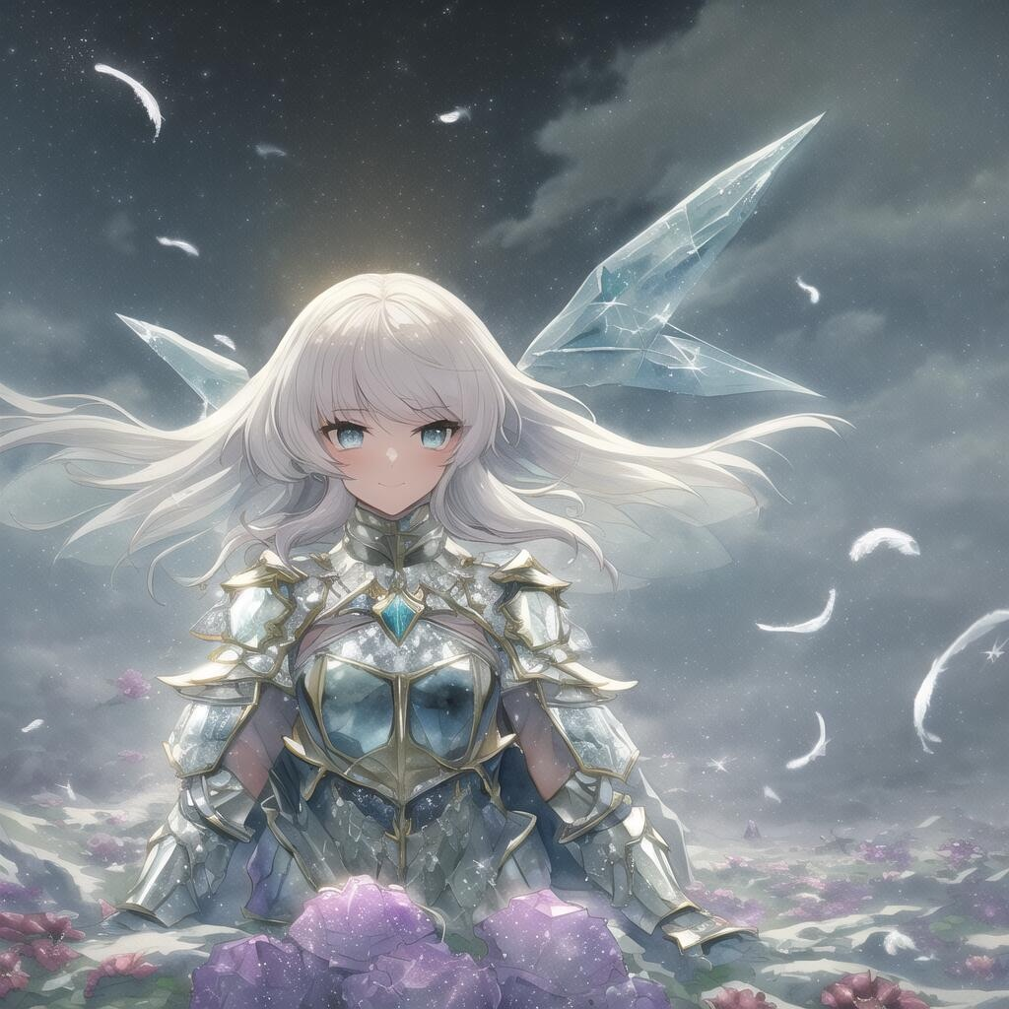
- 作者：LiON（QQ 3170885344）
- 作者的话：与其说是水晶，不如说这个质感其实更重要一些。水晶其实也完全可以换成别的东西。这个例图有用了群里的kegocha pt，去掉应该也没什么问题。
- 正面tag：
- masterpiece,{{{best quality}}},(illustration)),{{{extremely detailed CG unity 8k wallpaper}}},game_cg,(({{1girl}})),{solo}, (beautiful detailed eyes),((shine eyes)),goddess,fluffy hair,messy_hair,ribbons,hair_bow,{flowing hair}, (glossy hair), (Silky hair),((white stockings)),(((gorgeous crystal armor))),cold smile,stare,cape,(((crystal wings))),((grand feathers)),((altocumulus)),(clear_sky),(snow mountain),((flowery flowers)),{(flowery bubbles)},{{cloud map plane}},({(crystal)}),crystal poppies,({lacy}) ({{misty}}),(posing sketch),(Brilliant light),cinematic lighting,((thick_coating)),(glass tint),(watercolor),(Ambient light),long_focus,(Colorful blisters),ukiyoe style
- 反面tag：
- lowres, bad anatomy, bad hands, text, error, missing fingers, extra digit, fewer digits, cropped, worst quality, low quality, normal quality, jpeg artifacts, signature, watermark, username, blurry
- 参数：
- Steps: 45, Sampler: Euler, CFG scale: 6.5

水森法
- 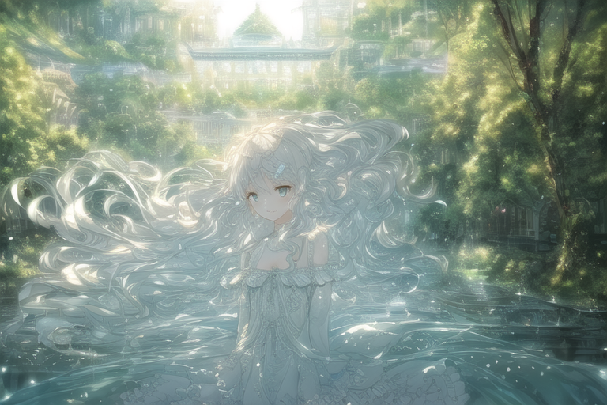
- 作者：凌霜雪猫（QQ 3347185525）
- 有宫殿的森林水世界
- 正面tag：
(extremely detailed CG unity 8k wallpaper),(((masterpiece))), (((best quality))), ((ultra-detailed)), (best illustration),(best shadow), ((an extremely delicate and beautiful)),dynamic angle,floating, solo,((1girl)),{long wavy curly hair},expressionless,((white idol dress)), anglesailor dress,(detailed wet clothes),silk shawl,bikini,underboob, frills,cute anime face,blush,(beautiful detailed eyes), (detailed light),feather, nature, (sunlight), river, (forest),(((floating palace))),beautiful and delicate water,(painting),(sketch),(bloom),(shine),
- 反面tag：
- lowres, bad anatomy, bad hands, text, error, missing fingers, extra digit, fewer digits, cropped, worst quality, low quality, normal quality, jpeg artifacts, signature, watermark, username, blurry,Missing limbs,three arms, bad feet,text font ui,signature,blurry,text font ui,malformed hands,long neck,limb,Sleeveles,bad anatomy disfigured malformed mutated,(mutated hands and fingers :1.5).(long body :1.3),(mutation ,poorly drawn :1.2), bad anatomy, disfigured, malformed, mutated,multiple breasts,futa,yaoi,three legs
- 参数：
- Steps: 40-50, Sampler: Euler, CFG scale: 4-7

冰火法
- 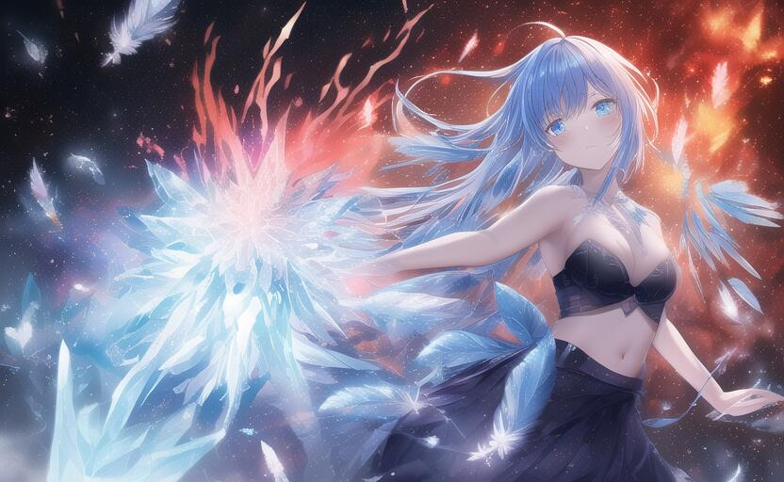
- 作者：風華-桜雪（QQ 416179437）
- 作者的话：还不太稳定，有时候偏火有时候偏冰，大多情况没问题
- 正面tag：
- ((ink)),((watercolor)),{{best quality},(expressionless),((illustration)),(beautiful detailed girl),(beautiful detailed eyes),world masterpiece theater,depth of field,(blue spark),anime face,black gauze skirt,(red and blue hair),blue eyes,focus_on_face,medium_breasts,(((((messy_long_hair))))),Bare shoulder,very_close_to_viewers,burning sky,navel,((bustier)),flame,Rainbow in the sky,((Flames burning ice)),(((Fire butterflys ))),(((ice crystal texture wings))),(Flying sparks),(detailed ice),{{a lot of luminous ice crystals}},((burning feathers)),{feathers_made_of_ice},(frozen feathers),{{{ice and fire together}}}
- 反面tag：
lowres,bad anatomy,bad hands, text, error, missing fingers,extra digit, fewer digits, cropped, worstquality, low quality, normal quality,jpegartifacts,signature, watermark, username,blurry,bad feet
- 参数：
steps:23 scale:4.5 euler 832x512

龙骑士
- 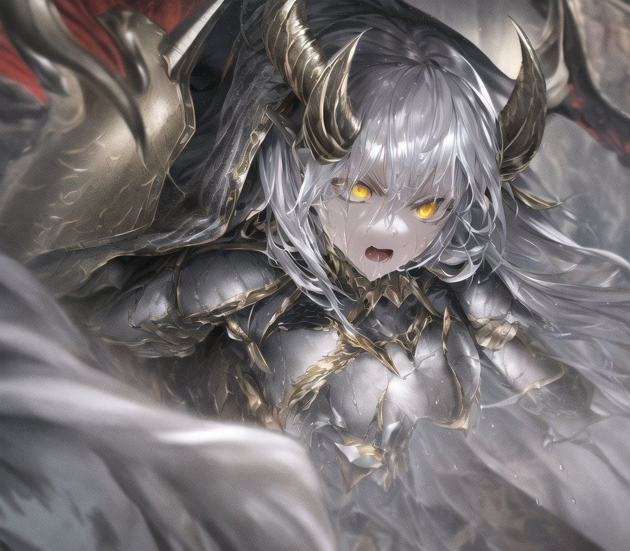
- 作者：好好怪（QQ 1395768464）
- “能不能跑出来随缘，但是tag没问题 ”
- 正面tag：
- extremely detailed CG unity 8k wallpaper, (masterpiece), best quality, illustration, (1 girl), wet skin, expressionless, yellow eyes, (anger), horns, (silver armor), metal, complex pattern, corner, cape, indifference
- 反面tag：
lowres, bad anatomy, bad hands, text,error, missing fngers,extra digt ,fewer digits,cropped, wort quality ,low quality,normal quality, jpeg artifacts,signature,watermark, username, blurry, bad feet，blush，helmet
- 参数：
- Steps: 50, Sampler: DDIM, CFG scale: 7

坠落法
- 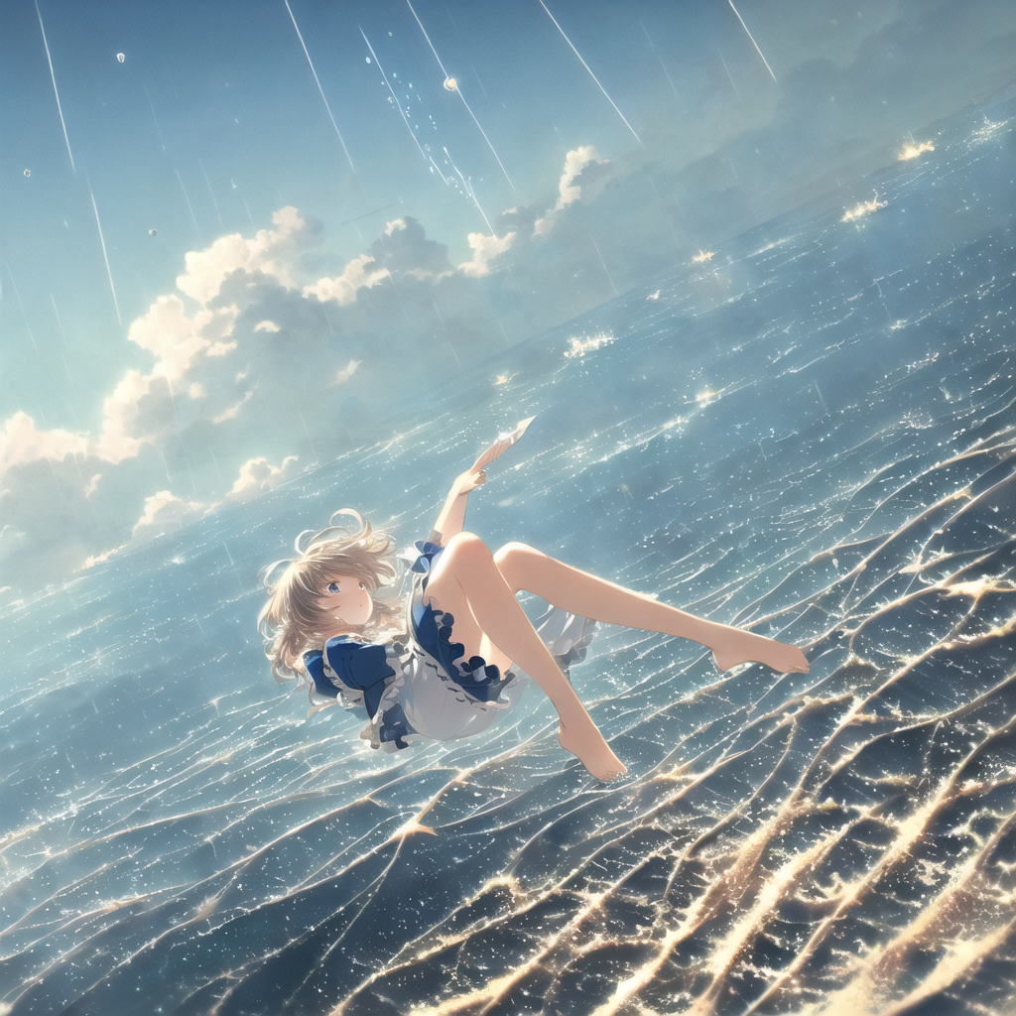
- 作者：ALICExhcm（QQ 1013372977）
- “坠落与浮空，真实与梦境，绝望与无助，泪水与笑容 ”
- 正面tag：
- ((masterpiece)),(((best quality))),((ultra-detailed)),((((full body)))),(unhelpless),tear,crying,((((( falling from the sky))))),(( Weathering With You)),(((full body))),(illustration), (1 girl),((falling))，tear,((face towards the sky))，(hair flows upwards)，((illustration)),((disheveled hair)),anime screeshot,((frills)),(1 girl),big top sleeves, floating,beautiful detailed isky,beautiful detailed eyes,overexposure,,expressionless,side blunt bangs,hairs between eyes, ribbons,bowties,buttons,bare shoulders,(((small breast))), detailed clothes,blank stare
- 反面tag：
((((ugly)))),(((duplicate))),((morbid)),((mutilated)),(((tranny))),(((trans))),(((trannsexual))),(hermaphrodite),(out of frame),extra fingers,mutated hands,((poorly drawn hands)),((poorly drawn face)),(((mutation))),(((deformed))),((ugly)),blurry,((bad anatomy)),(((bad proportions))),((extra limbs)),cloned face,(((disfigured))),(((more than 2 nipples))),out of frame,ugly,extra limbs,(bad anatomy),gross proportions,(malformed limbs),((missing arms)),((missing legs)),(((extra arms))),(((extra legs))),mutated hands,(fused fingers),(too many fingers),(((long neck))),lowres,bad anatomy,bad hands,text,error,missing fingers,extra digit,fewer digits,cropped,worst quality,low quality,normal quality,jpeg artifacts,signature,watermark,username,blurry,text font ui,malformed hands,long neck,missing limb,bad anatomy disfigured malformed mutated,(mutated hands and fingers 1,5),(long body 1,3),(mutation poorly drawn 1,2),bad anatomy disfigured malformed mutated,multiple breasts,bad feet
lowres,bad anatomy,bad hands,text,error,missing fingers,extra digit,fewer digits,cropped,worst quality,low quality,normal quality,jpeg artifacts,signature,watermark,username,blurry,text font ui,malformed hands,long neck,missing limb,Sleeveles,bad anatomy disfigured malformed mutated,(mutated hands and fingers 1,5),(long body 1,3),bad anatomy disfigured malformed mutated,multiple breasts,bad feet,futa,yaoi
- 参数：
- PLMS, steps 150, cfg 8

水下法
- 
- 作者：ᵐᵃʰⁱʳᵘ（QQ 1273348952）
- ᵐᵃʰⁱʳᵘ：“ 快给我加水下魔法，别让我求你 ”
- 正面tag：
- (((masterpiece))),(((best quality))),((ultra-detailed)),((underwater)),(illustration),(beautiful detailed water),((coral)),open tuck,((extremely delicate and beautiful girls)),dynamic angle,floating,(beautiful detailed eyes),(detailed light),(loli),floating hair,glowing eyes,pointy ears,(splash),underwater),((fishes)),white hair,green right eye,iceblue left eye,leaves dress,feather,nature,(sunlight),(underwater forest),(painting),(bloom),(detailed glow),drenched,seaweed,fish,(((Tyndall effect))),face to face
- 反面tag：
- lowres, bad anatomy, bad hands, text, error, missing fingers, extra digit, fewer digits, cropped, worst quality, low quality, normal quality, jpeg artifacts, signature, watermark, username, blurry,missing fingers,bad hands,missing arms,large breasts
- 参数：
- Steps: 27, Sampler: Euler a, CFG scale: 7

秘境法
- 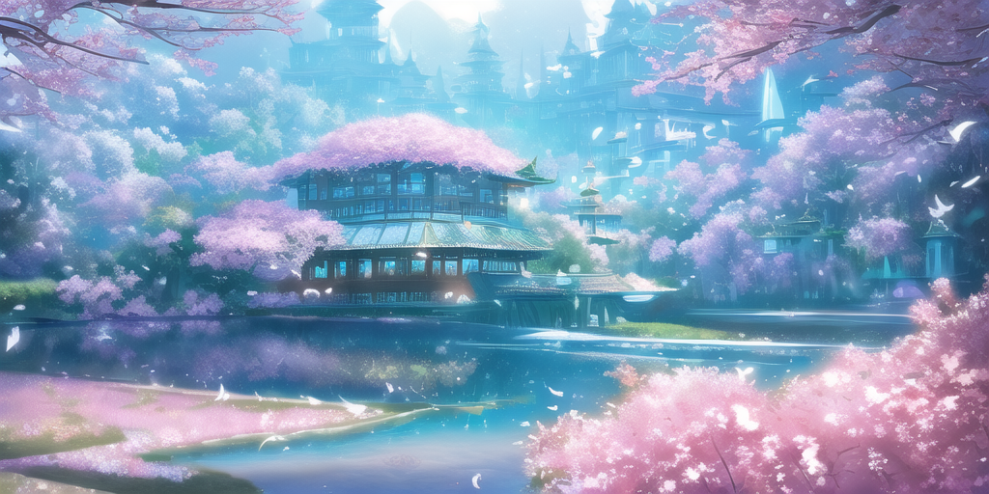
- 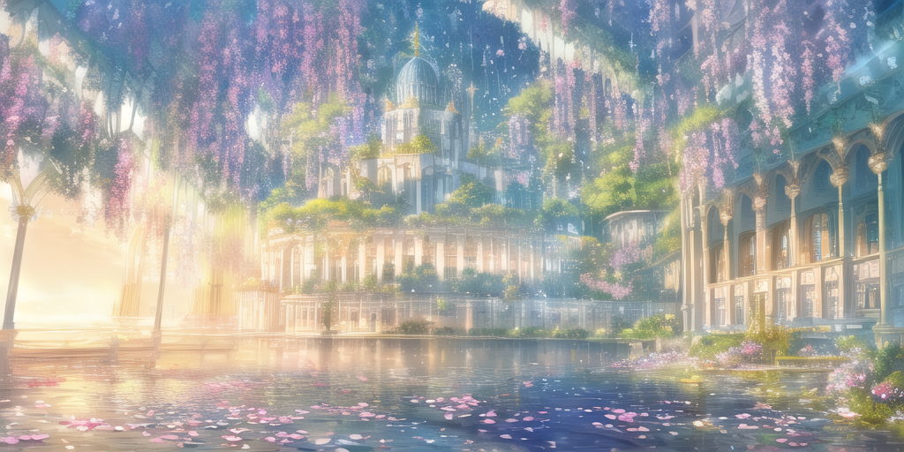
- 作者：凌霜雪猫（QQ 3347185525）
- “我只想说美炸了 ”
- 正面tag：
(extremely detailed CG unity 8k wallpaper),(((masterpiece))), (((best quality))), ((ultra-detailed)), (best illustration),(best shadow), ((an extremely delicate and beautiful)),dynamic angle,floating, fairyland,dynamic angle,sea of flowers,beautiful detailed garden,wind,classic,spring, (detailed light),feather, nature, (sunlight), river, forest,(((floating palace))),((the best building)),beautiful and delicate water,(painting),(sketch),(bloom),(shine)
- 反面tag：
- lowres, bad anatomy, bad hands, text, error, missing fingers, extra digit, fewer digits, cropped, worst quality, low quality, normal quality, jpeg artifacts, signature, watermark, username, blurry,Missing limbs,three arms, bad feet,text font ui,signature,blurry,text font ui,malformed hands,long neck,limb,Sleeveles,bad anatomy disfigured malformed mutated,(mutated hands and fingers :1.5).(long body :1.3),(mutation ,poorly drawn :1.2), bad anatomy, disfigured, malformed, mutated,multiple breasts,futa,yaoi,three legs
- 参数：
- CFG=6, Euler

摄影法
- 
- 作者：半生为夏甗麦至冬（QQ 167894905）
- “从立项开始没有一张丑的，我的评价是神咒 ”
- 除此以外，“ 随时支持添加人物，只需要增加一段人物通用负面 tag 就行 ”
- 正面tag：
{{{masterpiece}}}, {{the best quality, super fine illustrations, beautiful and delicate water}}, {{very delicate light}}, {{nature, painting}}, {{fine lighting, more transparent stars, high-quality snowflakes, high-quality mountains, very fine 8KCG wallpapers}}, (plateau), (((snow mountain))), sunrise, randomly distributed clouds, (snow field), cliff, ((rotating star sky)), ((lake in mountain stream)), luminous particles
- 反面tag：
- Negative prompt: Inverted mountain, low-quality, flowers, grass, distorted mountain, distorted light, low-quality light, low-quality mountain, low-quality illustration, low-quality background
- 参数：
- Steps: 30, Euler a, CFG7

望穿水
- 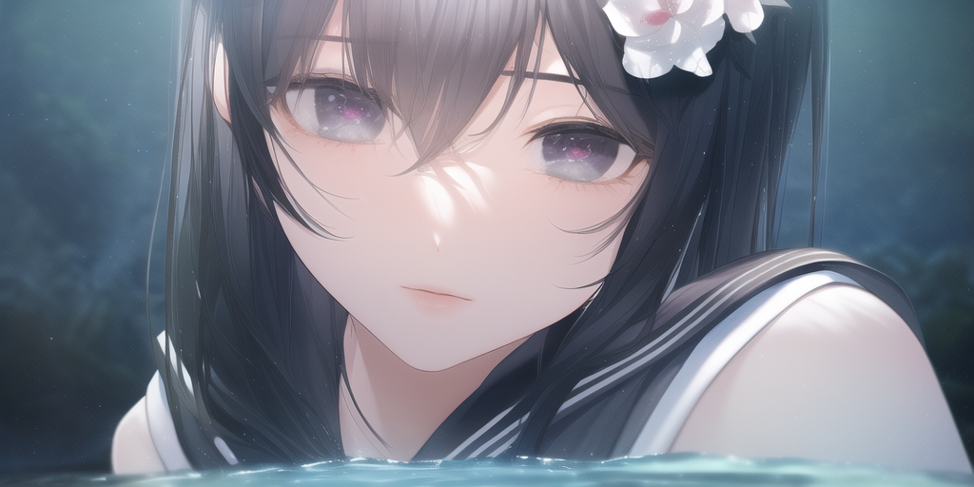
- 作者：丽普露·洛斯达（QQ 869581936）
- 全名：“浮水魔法”：
- 浮水魔法：这只是一个随意拼接而已，当你把镜头语言说明白了，这就很容易做到
- 正面tag：
- extremely detailed CG unity 8k wallpaper,best quality，noon,beautiful detailed water，long black hair，beautiful detailed girl，serafuku,view straight on,eyeball,hair flower,close up
- 反面tag：
lowres, bad anatomy, bad hands, text, error, missing fingers, extra digit, fewer digits, cropped, worst quality, low quality, normal quality, jpeg artifacts, signature, watermark, username, blurry, bad feet,artist name,more than 2 thighs,nsfw,
- 参数：
- 26step, cfg 6

天选术
- 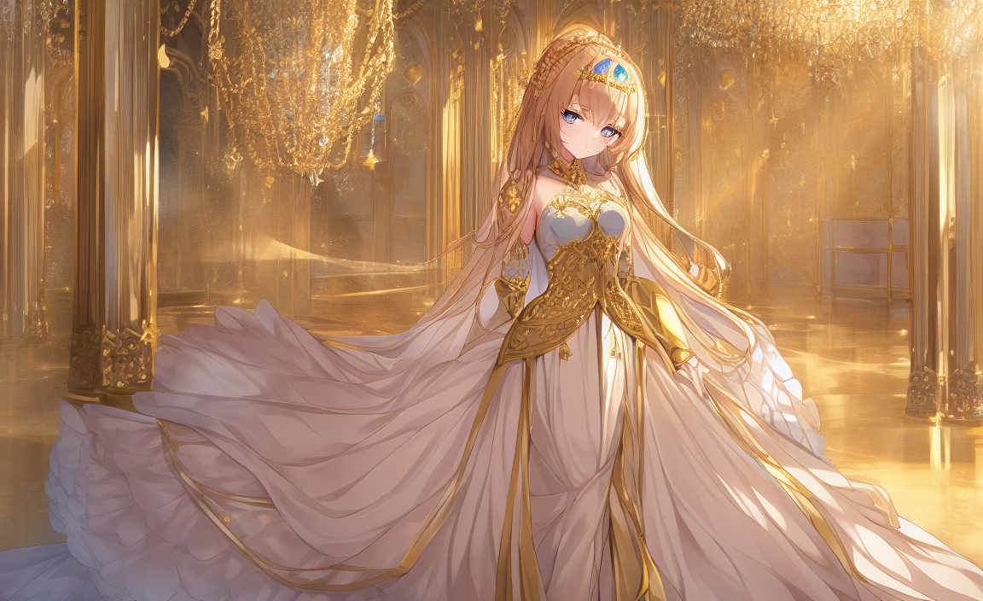
- 作者：丽普露·洛斯达（QQ 869581936）
- 天选术：这是对所有乙方的敬意，感谢乙方的付出，这次让我们善待乙方，请Ai老师为我们选出最好的图吧！
- 正面tag：
Please draw a picture of an exquisite girl in a princess dress with delicate gold metal decorations. She stands there looking at me
- 反面tag：
- lowres, bad anatomy, bad hands, text, error, missing fingers, extra digit, fewer digits, cropped, worst quality, low quality, normal quality, jpeg artifacts, signature, watermark, username, blurry, bad feet,artist name,more than 2 thighs,nsfw
- 参数：
- 26step, cfg 6

摩登法
- 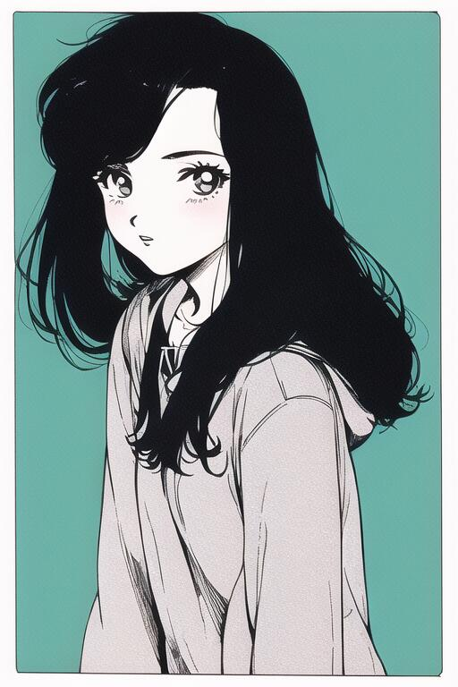
- 作者：Phoebe（QQ 3101516445）
- “固有结界·蒸汽艺术”
- 编者注：我已经审美疲劳了，这个来的好啊（
- 正面tag：
- {{{{retro artstyle}}}}, {{masterpiece)),best quality,illustration,1 girl,mature female,small breast,beautiful detailed eyes,long sleeves, hoodie,frills, no shadow, simple background, bright skin, 1980s (style)
- 反面tag：
- lowres,bad anatomy,bad hands,text,error,missing fingers,extra digit,fewer digits,cropped,worst quality,low quality,normal quality,jpeg artifacts,signature,watermark,username,blurry,bad feet,ugly,duplicate,trannsexual,hermaphrodite,out of frame,extra fingers,mutated hands,poorly drawn hands,poorly drawn face,mutation,deformed,blurry,bad anatomy,bad proportions,extra limbs,cloned face,disfigured,more than 2 nipples,out of frame,ugly,extra limbs,bad anatomy,gross,worst quality,low quality,normal quality,signature,watermark,username,blurry,proportions,malformed limbs,missing arms,missing legs,extra arms,extra legs,mutated hands,fused fingers,too many fingers,long neck
- 参数：
- Steps: 30, Sampler: Euler a, CFG scale: 6.5

血魔法
- 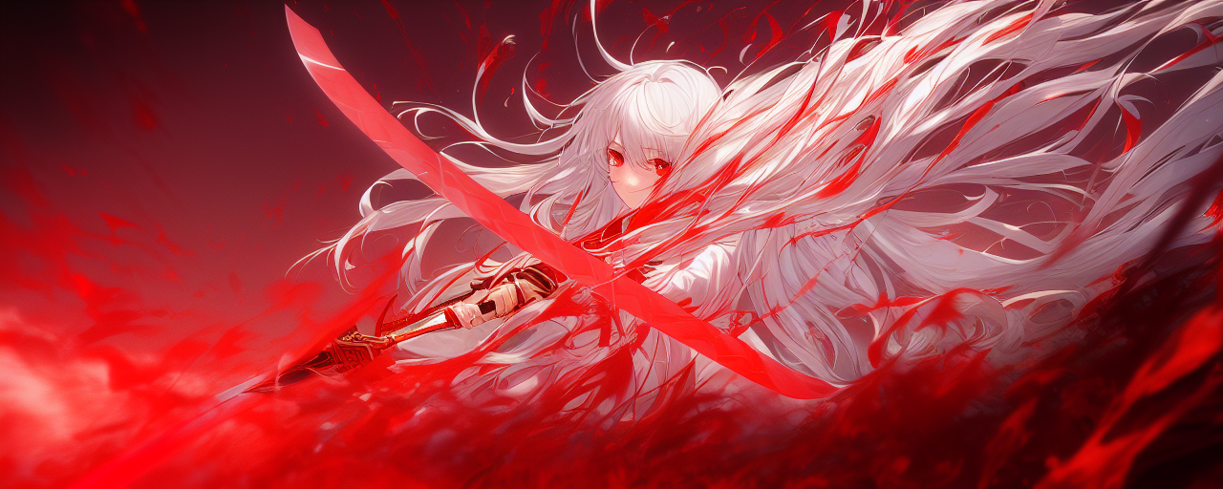
- 作者：千秋夢（QQ 1798780261）
- 编者注：帅死我了呜呜呜
- 编者注：更新了，新的精简代码替换了之前的繁琐和冗余的那一大堆，蛮不错的。
- 正面tag：
masterpiece, best quality, best quality,Amazing,1girl,finely detail,Depth of field,extremely detailed CG unity 8k wallpaper, masterpiece, full body,(loli),(white hair), red streaked hair, red eyes, (full body),red hair, (((with sword))), angry face，(beautiful detailed eyes), Blood drop,Blood fog, floating hair,light shafts, soft focus, character focus,disheveled hair,long bangs, hairs between eyes, looking at viewer,lowing hair, floating, Splashing blood,Long hair,(Bloodstain)
- 反面tag：
multiple breasts, (mutated hands and fingers:1.5 ), (long body :1.3), (mutation, poorly drawn :1.2) , liquid body,malformed, mutated, text font ui,malformed hands, long neck, lowres, bad anatomy, bad shadow, uncoordinated body, fused ears
- 参数：
- Steps: 25, Sampler: Euler a, CFG scale: 7

绚丽术
- 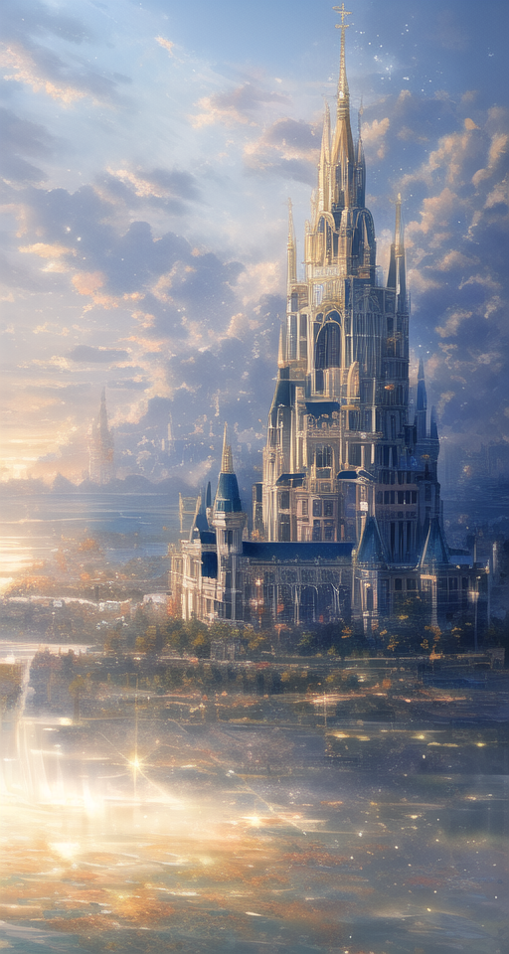
- 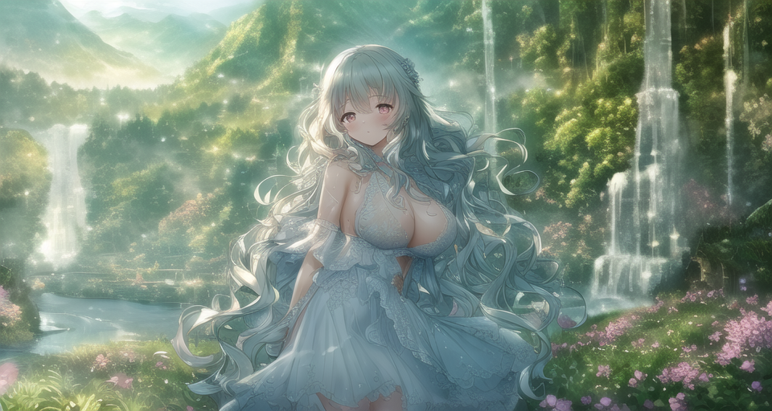
- 作者：凌霜雪猫（QQ 3347185525）
- “实际上这个是一种细致的画风，中间不一定是城堡，换成描述细节的人也可以”
- 正面tag：
(extremely detailed CG unity 8k wallpaper),(((masterpiece))), (((best quality))), ((ultra-detailed)), (best illustration),(best shadow), ((an extremely delicate and beautiful)),dynamic angle,floating,

The detailed castle, (((the best building))),

- mist encircles the mountains,fairyland,dynamic angle,classic,(detailed light),feather, nature, (sunlight), river, forest,flowers,beautiful and delicate water,(painting),(sketch),(bloom),(shine)
- 反面tag：
- Inverted mountain, low-quality,low-quality illustration, low-quality background, lowres, bad anatomy, bad hands, text, error, missing fingers, extra digit, fewer digits, cropped, worst quality, low quality, normal quality, jpeg artifacts, signature, watermark, username, blurry,Missing limbs,three arms, bad feet,text font ui,signature,blurry,text font ui,malformed hands,long neck,limb,Sleeveles,bad anatomy disfigured malformed mutated,(mutated hands and fingers :1.5).(long body :1.3),(mutation ,poorly drawn :1.2), bad anatomy, disfigured, malformed, mutated,multiple breasts,futa,yaoi,three legs
- 参数：
- CFG=6, Euler

唤龙术
- 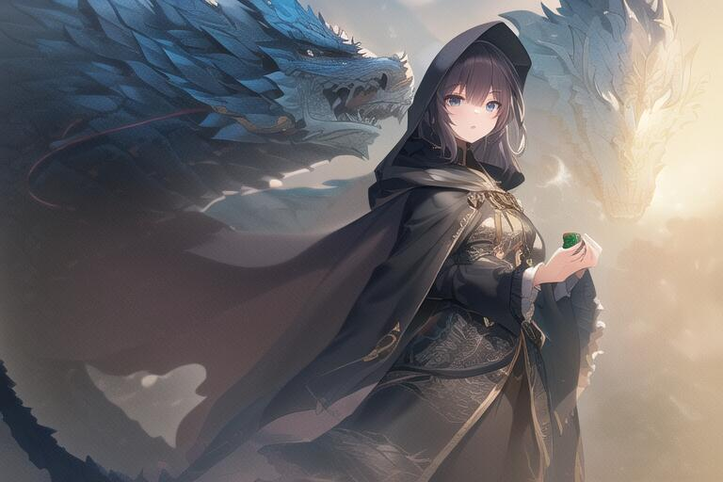
- 作者：Phoebe（QQ 3101516445）
- 作者的话：有时候可能会出现没有人只有龙的情况（
- “如果担心不会出龙的话，加强 Loong, dragon background, loong background这几个tag的权重”
- 正面tag：
- ((masterpiece)),(((best quality))),illustration,1 girl,mature female,small breast,beautiful detailed eyes,long sleeves, hoodie,frills, extremely detailed CG unity 8k wallpaper, Loong, dragon background, loong background, game cg, depth of field, Cape hood
- 反面tag：
- lowres,bad anatomy,bad hands,text,error,missing fingers,extra digit,fewer digits,cropped,worst quality,low quality,normal quality,jpeg artifacts,signature,watermark,username,blurry,bad feet,ugly,duplicate,trannsexual,hermaphrodite,out of frame,extra fingers,mutated hands,poorly drawn hands,poorly drawn face,mutation,deformed,blurry,bad anatomy,bad proportions,extra limbs,cloned face,disfigured,more than 2 nipples,out of frame,ugly,extra limbs,bad anatomy,gross,worst quality,low quality,normal quality,signature,watermark,username,blurry,proportions,malformed limbs,missing arms,missing legs,extra arms,extra legs,mutated hands,fused fingers,too many fingers,long neck
- 参数：
- Steps: 40, Sampler: Euler, CFG scale: 7

龙机法
- 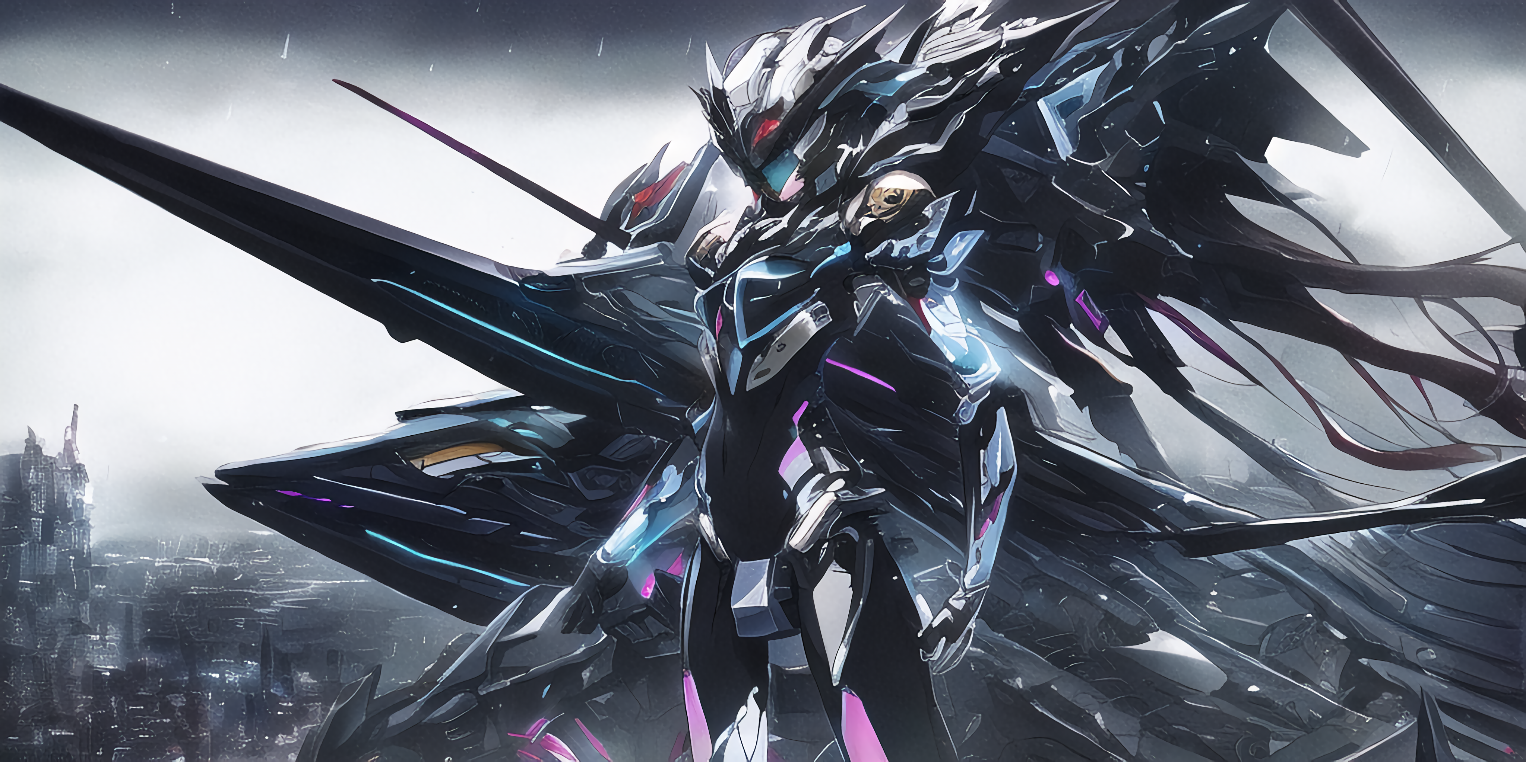
- 作者：孤辰Null（QQ 2659055918）
- “没人任何一个男人能拒绝机娘!如果有，那就再加条龙！”
- 编者注：帅啊，但是这人的脸呢（
- 正面tag：
- {{master piece}},best quality,illustration,1girl,small breast,beatiful detailed eyes,beatiful detailed cyberpunk city,flat_chest,beatiful detailed hair,wavy hair,beatiful detailed steet,mecha clothes,robot girl,cool movement,sliver bodysuit,{filigree},dargon wings,colorful background,a dragon stands behind the girl,rainy days,{lightning effect},beatiful detailed sliver dragon arnour，（cold face）
- 反面tag：
{{{ugly}}},{{{duplicate}}},{{morbid}},{{mutilated}},{{{tranny}}},mutated hands,{{{poorly drawn hands}}},blurry,{{bad anatomy}},{{{bad proportions}}},extra limbs,cloned face,{{{disfigured}}},{{{more than 2 nipples}}},{{{{missing arms}}}},{{{extra legs}}},mutated hands,{{{{{fused fingers}}}}},{{{{{too many fingers}}}}},{{{unclear eyes}}},lowers,bad anatomy,bad hands,text,error,missing fingers,
- 参数：
- ddim, steps 23, cfg 4.5

战姬法
- 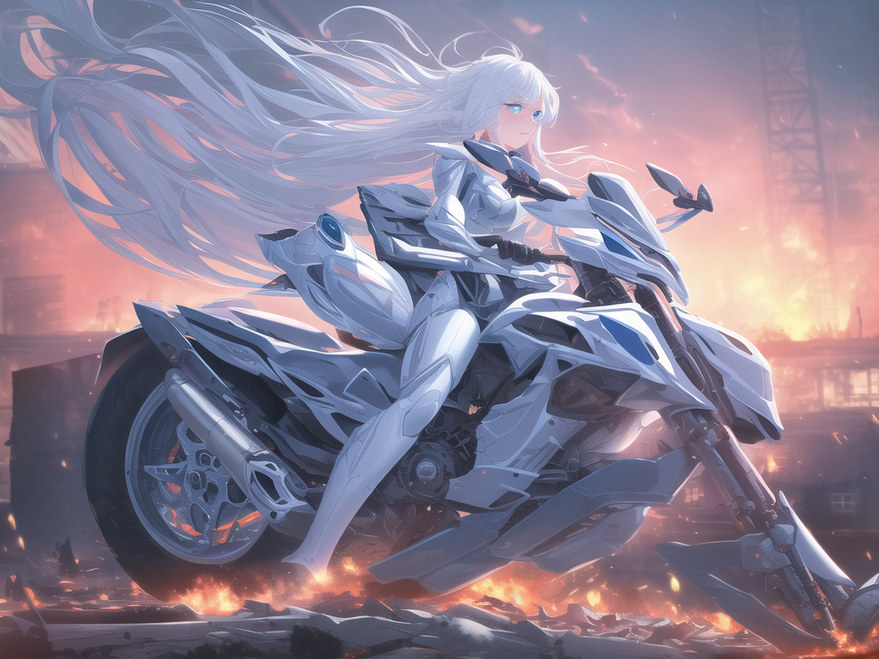
- 作者：alleoha（QQ 3355401391）
- “原名叫《战争少女》，mechanical armor 是机甲的关键词汇， ruins of city in the war,fire, burning buildings是背景关键词。”
- 正面tag：
- {{{solo}}},highres,{best quality};{highly detailed},beautiful detailed blue eyes,light blush,expressionless,white hair,hair fluttering in the wind,mechanical arm armor,mechanical body armor,clothes,riding motor,{bodysuit,ruins of city in war,fire,burning cars,burning buildings,air force fleet in the sky,dusk,bird see
- 反面tag：
lowres, bad anatomy, bad hands, text, error, missing fingers, extra digit, fewer digits, cropped, worst quality, low quality, normal quality, jpeg artifacts, signature, watermark, username, blurry, bad feet,lowres, bad anatomy, bad hands, text, error, missing fingers, extra digit, fewer digits, cropped, worst quality, low quality, normal quality, jpeg artifacts, signature, watermark, username, blurry
- 参数：
- Steps: 50, Sampler: Euler a, CFG scale: 5

炼银术
- 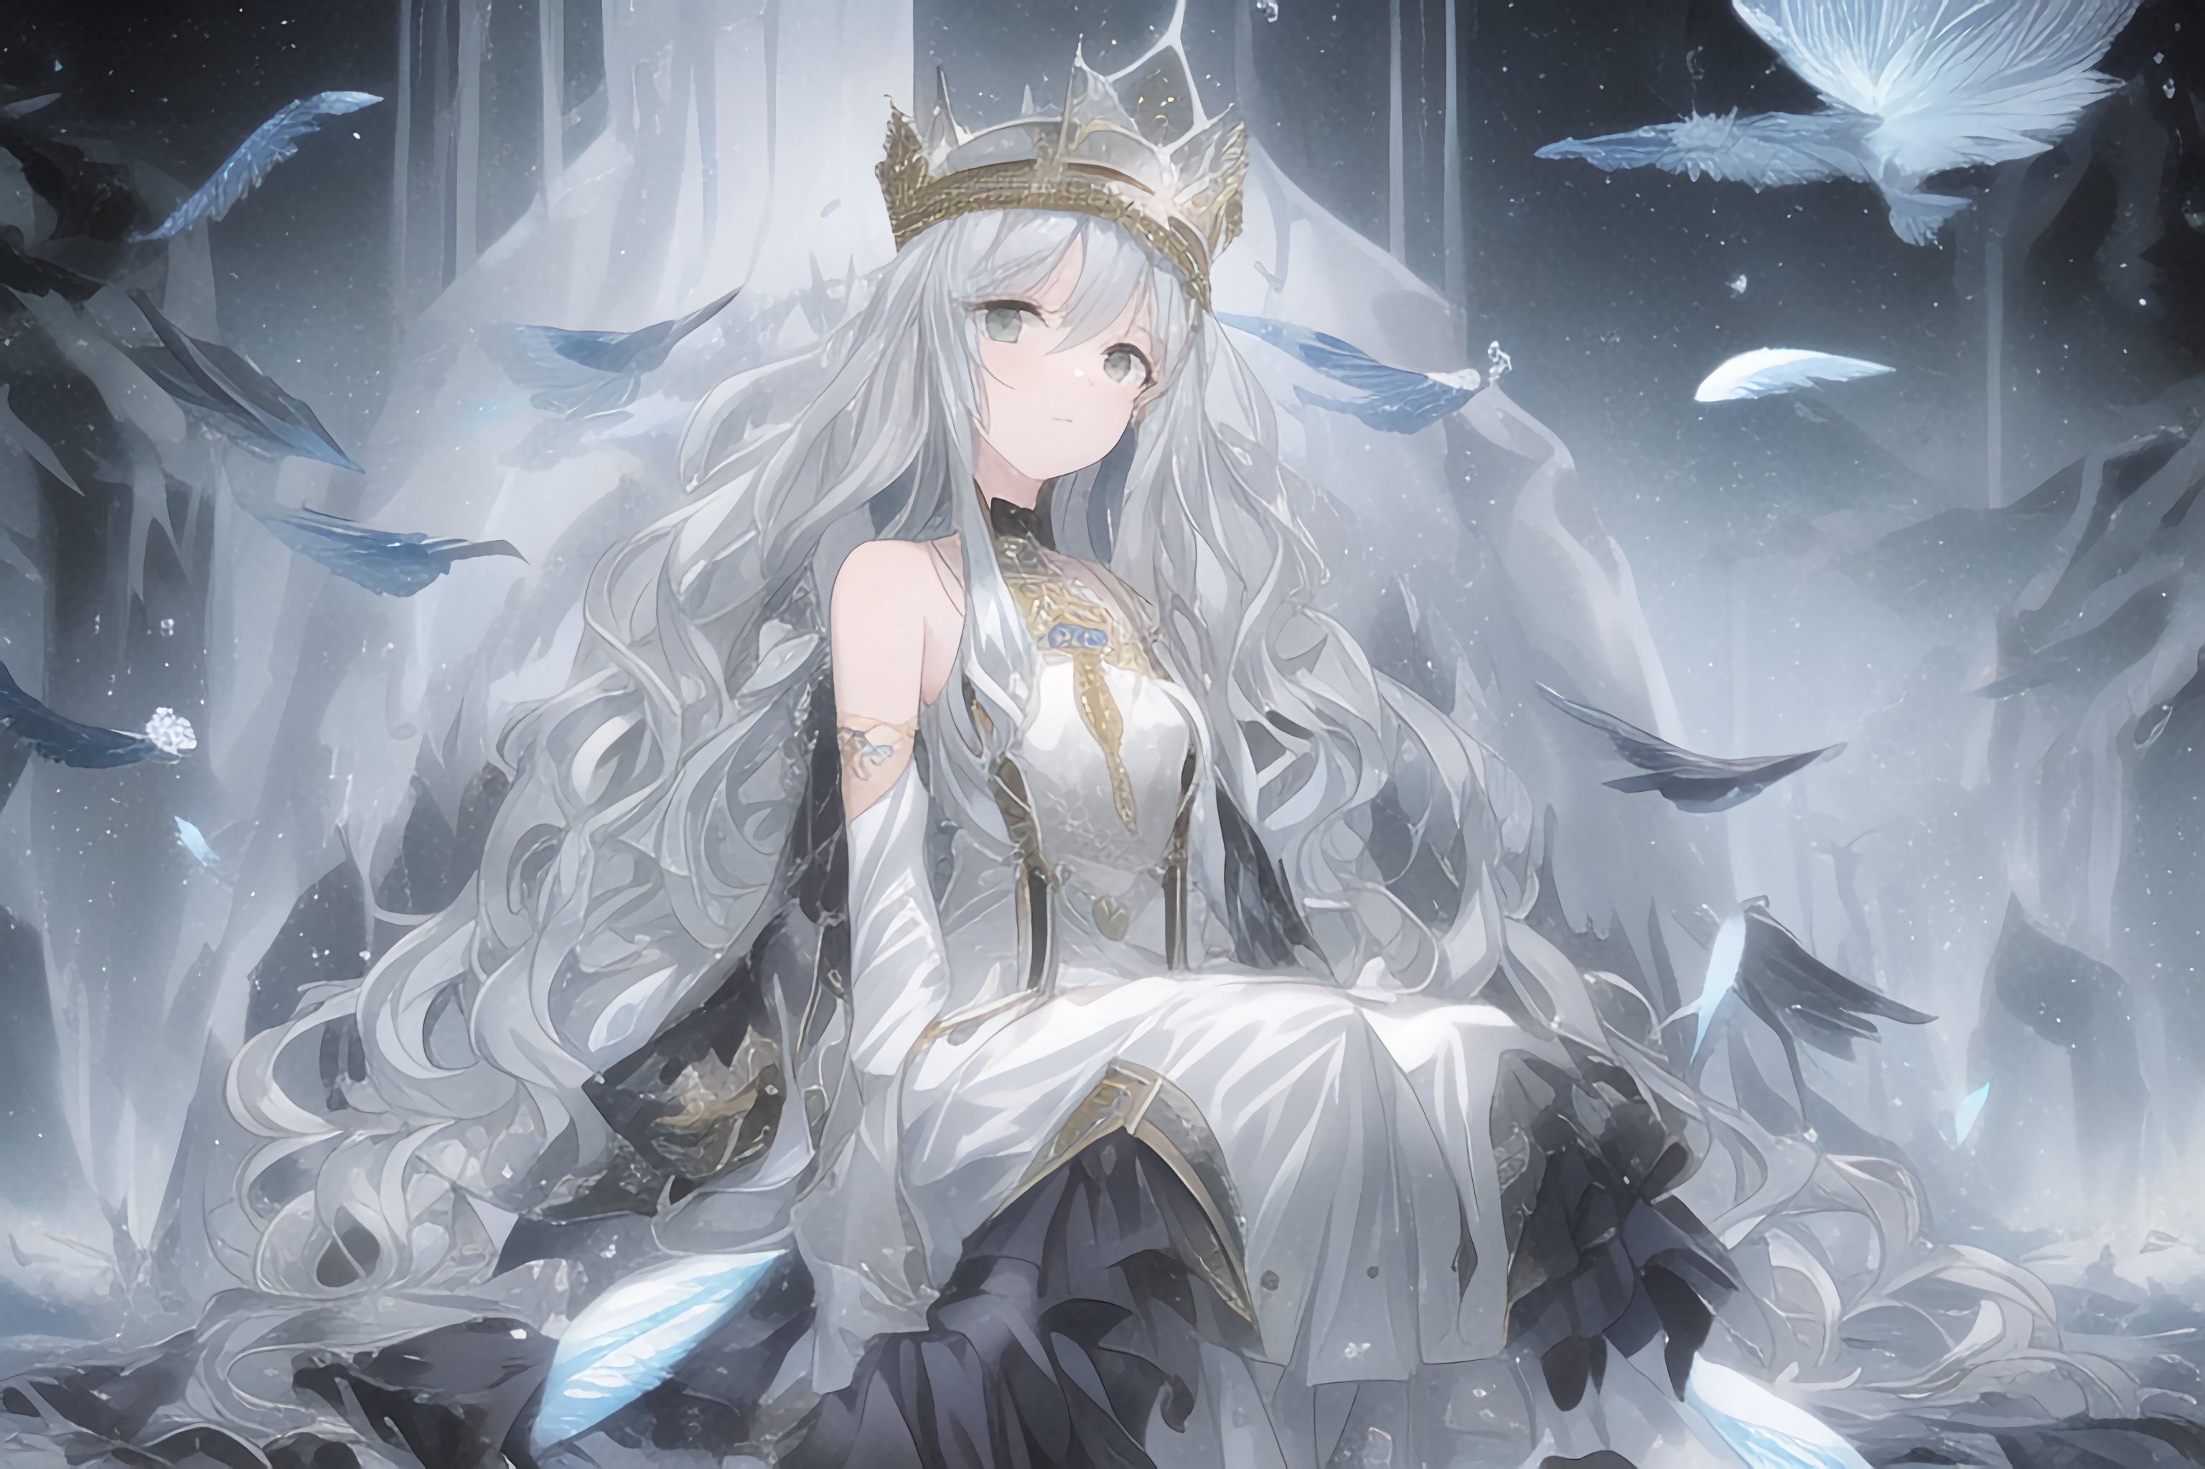
- 作者：孤辰Null（QQ 2659055918）
- “ 姐姐踩我! ”
- 编者注：这是一个极其出色的tag，无论是tag长度还是画面效果都非常惊艳。
- 编者注2：原名《银王座》，由于去掉王座效果更好，遂更名。
- 正面tag：
- (((masterpiece))),best quality, illustration,(beautiful detailed girl), a girl ,solo,bare shoulders,flat_chst,diamond and glaring eyes,beautiful detailed cold face,very long blue and sliver hair,floaing black feathers,wavy hair,black and white sleeves,gold and sliver fringes,a (blackhole) behind the girl,a silver triple crown inlaid with obsidian,(sit) on the black ((throne)), (depth) of (field)
- 反面tag：
- 1,bad feet_hand_finger_leg_eye,missing fingers,worst low normal quality,bad face,blurry:1.1,Asymmetrical eyes,Simple background
- 参数：
- naifu 步骤23 规模4.5 采样ddim

星源法
- 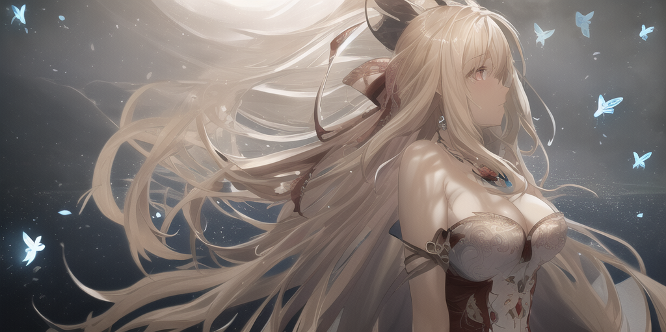
- 作者：樱の雪（QQ 2923350844）
- “星河浩瀚，宇宙无垠，创意无限！我要更多的大召唤术式！我要看涩图！cfg scale 2~20都是不同的风格哦 大伙可以自己试试 ”
- 正面tag：
best quality,Amazing,Beautiful golden eyes,finely detail,Depth of field,extremely detailed CG unity 8k wallpaper, masterpiece,(((Long dark blond hair))),((red mediumhair)),(1 girl),(white stockings ),(((((medium_breasts,))))),(hair ribbon),Exposing cleavage,((Beautiful butterflies in detail)),(((halter dress ))),huge ahoge,particle,(((solo))),(Background of details),standing,(Starry sky in beautiful detail),(((gloom (expression) depressed))),(Hazy fog),(((Very long hair))),{Fluttering hair},{Thick hair},{{{Gelatinous texture}}},{profile},(Ruins of beautiful details),(((Standing on the surface of the sea))),{Close-up of people},{{{Smooth skin}}},(((upper body))),(Smooth and radiant skin),(Smooth and radiant face),Perfect details,Beautifully gorgeous necklace,Authentic skin texture,{Cleavage},{{{Authentic and detailed face}}},(unexposed :1.5)
- 反面tag：
- lowres, bad anatomy, bad hands, text,error, missing fngers,extra digt ,fewer digits,cropped, wort quality ,low quality,normal quality, jpeg artifacts,signature,watermark, username, blurry, bad feet,nsfw
- 参数：
- Steps: 50, Sampler: Euler, CFG scale: 4

学院法
- 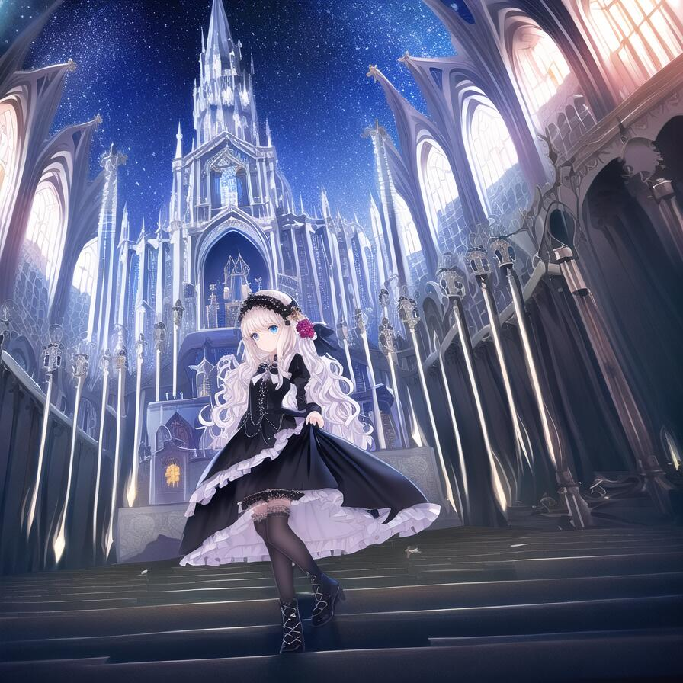
- 作者：東雲（QQ 1450999793）
- “兼有只生成人物的人物水平，和只生成背景的背景水平，改发色出的成品倾向也不一样（”
- 正面tag：
- {best quality}, {{masterpiece}}, {highres}, extremely detailed CG, extremely detailed 8K wallpaper, extremely detailed character, {an extremely delicate and beautiful}, portrait, illustration, solo focus, straight-on, dramatic angle, depthoffield, {{cinematiclighting}}, outdoors, {{{character({{{a girl}}}, solo, loli, {{{{full body}}}}, standing, expressionless, [[[light smile]]], cute, beautiful detailed eyes, blue eyes, [long legs], {very_long_hair}, blonde hair, wavy_hair, [shiny hair], {{Gothic_Lolita}}, blue_white skirt, {{short skirt}}, black_Headdress, bowknot, {{{hair ornament}}}, [hair flower], stocking, [[Garter]], Lace, cross-laced footwear, ribbon-trimmed sleeves)}}}, [background(building architecture, {{gothic architecture}}, starry sky, outdoors, church, {castle}, [[fantasy]])]
- 反面tag：
- lowres, polar lowres, bad anatomy, bad face, bad hands, bad body, bad shose, bad feet, bad proportions, {bad leg}, {{more legs}}, worst quality, low quality, normal quality, gross proportions, blurry, poorly drawn asymmetric eyes, text,error, missing fingers, missing arms, missing legs, short legs, extra digit, long skirt, indoors, 2girls, out of frame, only_upper body, only_lower body, {from above}, [petite], low background
- 参数：
- Steps: 70, Sampler: DDIM, CFG scale: 12

浮世绘
- 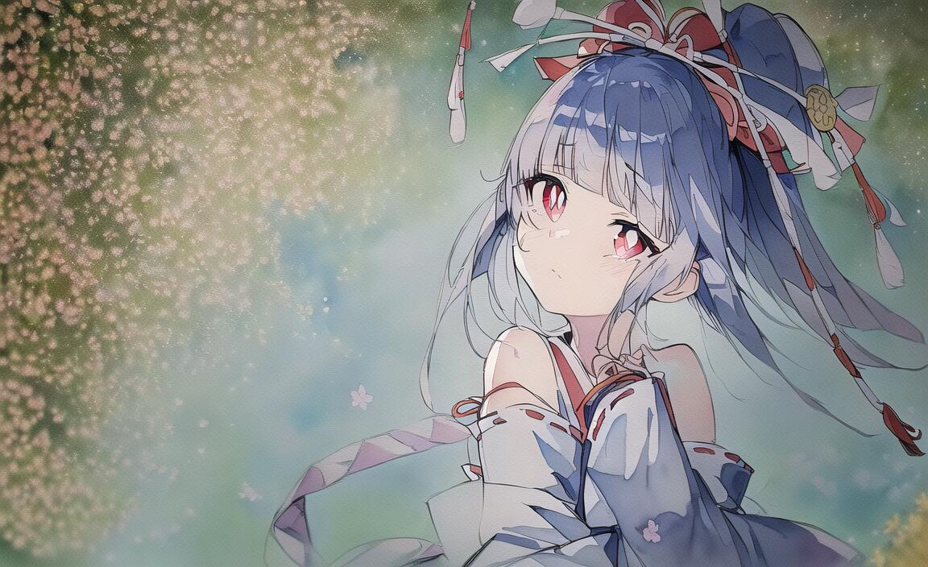
- 作者：老年痴呆的疾风法师（QQ 1431322374）
- “作者实在是太懒了，想不出来什么名字就笼统的用这个名字吧（”
- 正面tag：
(watercolor_medium), ((ukiyoe style)), ((((masterpiece)))), (((best quality))), (illustration),(1girl:1.5),(solo:1.5), ((an extremely delicate and beautiful)), ((little girl)) , cute, ((hime_cut)), side blunt bangs,(ultramarine hair:1.2), hairs between eyes, ribbons, Bracelet , bare shoulders,((japanese_clothes)), sakura, ((slit pupils)), ((miko)), (off_shoulder), ace, (Kagura Suzu),sword
- 反面tag：
lowres, bad anatomy, bad hands, text, error, missing fingers, extra digit, fewer digits, cropped, worst quality, low quality, normal quality, jpeg artifacts, signature, watermark, username, blurry,missing fingers,bad hands,missing arms, long neck, Humpbacked,shadow,nude,Unusual hands,Abnormal fingers,large breasts
- 参数：
Steps: 28, Sampler: DDIM, CFG scale: 11

星霞海
- 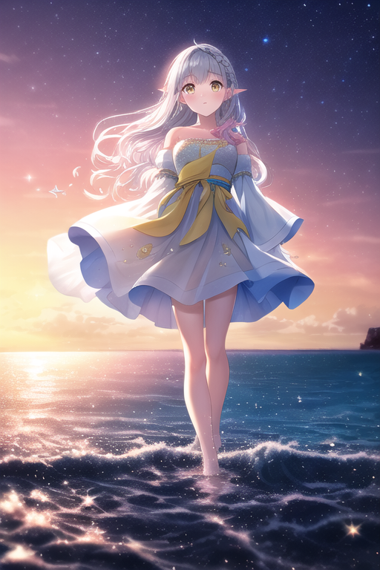
- 作者：明月珰（QQ 1816153515）
- “这个要用naifu跑才会拥有超高的优质出图率 可可爱爱才是最美好的 ”
- 正面tag：
dream,(((extremely detailed CG unity 8k wallpaper))),{painting},(((ink))),amazing,Depth of field,{{best quality}},{{masterpiece}},highres,dynamic angle,(illustration),cinematic lighting,{1girl},((wavy silver hair)),((loli)),((extremely_detailed_eyes_and_face)),(detailed flooding bare feet:1.5),translucent pink skirt,gemological hair,french braid,pointy ears,looking at viewer,{{translucent fluttering skirt}},yellow hairpin,{{white dress with pink lace with yellow decoration}},sleeves past wrists,((sleeves past fingers)),walking_motion,strapless dress,ocean waves,wind,(((glistening light of waves))),{detailed sunset glow},(floating flow),((coral)),(Luminous),coast,{floating colorful bubbles},beautiful detailed sky,{fluorescence},detailed shadow,(conch),beautiful detailed water,drenched,starfish,meteor,rainbow,(seabirds),{glinting stars}, (glowworm),(splash),,detailed cloud,shell,{fireworks}
- 反面tag：
malformed hands,worst quality,low quality,{{{{ugly}}}},{{{duplicate}}},{{{trans}}},{{trannsexual}},{out of frame},extra fingers,mutated hands,{{{more than 2 nipples}}},out of frame,extra limbs,{bad anatomy},grossproportions,{malformed limbs},{{missing arms}},{{missinglegs}},{{{extra arms}}},{{{extra legs}}},mutated hands,{fusedfingers},{{{long neck}}},fingers,extra digit,cropped,bad feet,{{poorly drawnhands}},{{poorly drawn face}},{{{mutation}}},{{deformed}},blurry,{{bad anatomy}},{{{bad proportions}}},{{extra_limbs}},{{{disfigured}}}.bad anatomy disfigured,malformed mutated,missing limb,normal quality,too many fingers,long neck,bad finglegs,cropped，bad feet,bad anatomy disfigured,malformed mutated,{{morbid}},{{mutilated}},{{{tranny}}},missing limb,malformed hands,
- 参数：
512 768, DDIM, step 45 cfg 10 NAIFU

冬雪法
- 
- 作者：陌桦（QQ 2503681391）
- “果然雪天还是要配白毛红瞳！”
- 正面tag：
- (((masterpiece))), (((best quality))), ((ultra-detailed)), (illustration),beautiful detailed sky ,night,stars,(1girl)((an extremely delicate and beautiful girl)),red eyes,dramatic angle,small breasts,(((full body))),hood,cold face and white shirt,(((long white hair))),(red hair),(red plum blossom),((winter)),(((snowflakes))){{{{{{detailed cute anime face}}}}}},cinmatic lighting,((red and white flowers))，hairs between eyes, expressionless, young girl,(((Facing the lens))),(starry sky),((Beautiful face)),((full body)),(sitting),depth_of_field,((colorful)),scenery,hair_flower,lantern,christmas,(starfall)
- 反面tag：
- (((ugly))),(((duplicate))),((morbid)),((mutilated)),(((tranny))),mutated hands,(((poorly drawn hands))),blurry,((bad anatomy)),(((bad proportions))),extra limbs,cloned face,(((disfigured))),(((more than 2 nipples))),((((missing arms)))),(((extra legs))),mutated hands,(((((fused fingers))))),(((((too many fingers))))),(((unclear eyes))),lowers,bad anatomy,bad hands,text,error,missing fingers,extra digit,fewer digits,cropped,worst quality,low quality,normal quality,jpeg artifacts,signature,watermark,username,blurry,bad feet，text font ui,malformed hands,long neck,missing limb,(mutated hand and finger: 1.5),(long body: 1.3),(mutation poorly drawn: 1.2),disfigured,malformed mutated,multiple breasts,futa,yaoi
- 参数：
- Steps: 50, Sampler: DDIM, CFG scale: 7

刻刻帝
- 
- 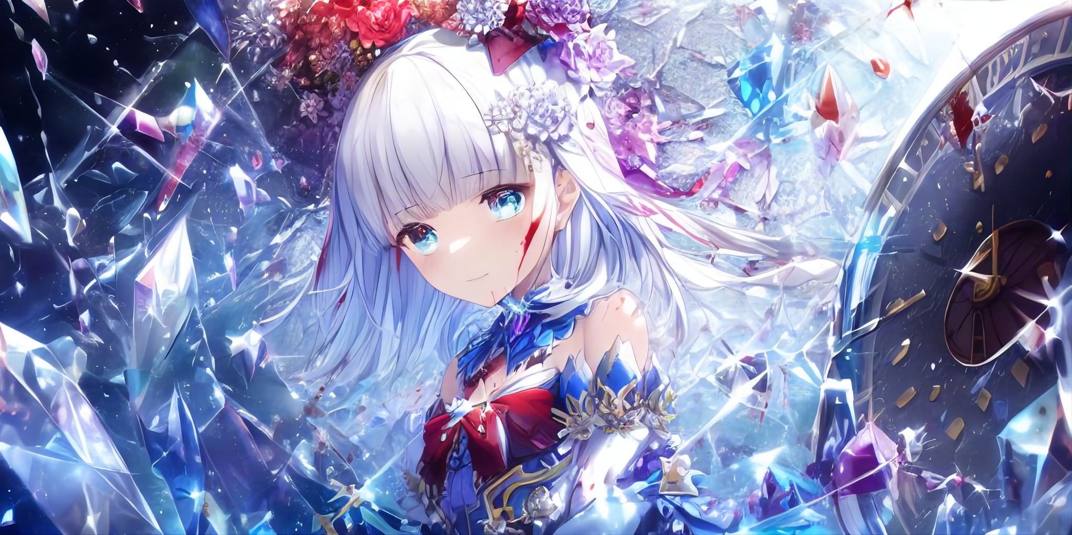
- 作者：离露（QQ 1123820886）
- “使用了部分水晶术的术法，成功率不是100%，可以多试试正咒 ”
- 编者注：这也是第一卷最后的一个魔法了。第二卷再见！
- 正面tag：
- (((crystals texture Hair)))，{{{{{extremely detailed CG}}}}},{{8k_wallpaper}},{{{{Crystalline purple gemstone gloves}}}},((beautiful detailed Glass hair)),((Glass shaped texture hand)),((Crystallize texture body)),Gem body,Hands as clear as jewels,Crystallization of clothes,((crystals texture skin)),sparkle, lens flare, light leaks, Broken glass，{{{{Detailed Glass shaped clothes}}}}， ((masterpiece)), (((best quality))), ((ultra-detailed)), ((illustration)), ((disheveled hair)), ((frills)), (1 girl), (solo), dynamic angle, big top sleeves, floating, beautiful detailed gemstone sky, gemstone sea, beautiful detailed eyes, overexposure, side blunt bangs, hairs between eyes, ribbons, bowties, buttons, bare shoulders, (((small breast))), pleated skirt, crystals texture flowers， ((Detailed crystallized clothing)),(gemstone of body)，solo focus,{{{{{{{{Iridescence and rainbow hair:2.5}}}}}}},{{{{{{detailed cute anime face}}}}}},{{loli}},{{{{{watercolor_(medium)}}}},(((masterpiece))),(((clock))),(((red))),(((blood))),finely detail,Depth of field,Blood drop,Blood fog
- 反面tag：
- lowres,bad anatomy,bad hands,text,error,ugly,duplicate,morbid,boken limb,incorrect limb,fusion finger,lose finger,multiple finger,multiple digit,fusion hand,lose leg,fused leg,multiple leg,bad feet,fewer digits,cropped,worst quality,low quality,normal quality,simple background,jpeg artifacts,signature,watermark,username,blurry,text font ui,malformed hands,long neck,missing limb,(mutated hand and finger: 1.5),(long body: 1.3),(mutation poorly drawn: 1.2),disfigured,malformed mutated,multiple breasts,futa,yaoi,big breasts
- 参数：
- Steps: 30, Sampler: Euler, CFG scale: 7

投稿模板：

某魔法
- 作者：（QQ ）
- 作者的话
- 正面tag：

- 反面tag：

- 参数：

- 编者注：

- 法典投稿基础要求：
- 1. 请各位赛博魔法师使用以上模板编辑为 word 文档，然后投稿至元素法典策划组邮箱 coqpc@outlook.com。投稿时请务必在邮件名内加上 #元素法典投稿# 并包含 word 文档，否则视为无效投稿。
- 2. 立意要新颖，避免同质化。新的画风/内容都是被欢迎的
- 3. 出图要稳定，至少50％的良品率，70％以上最佳
- 4. 请避免使用作家和版权限定的tag
- 5. Tag尽量精简，尽量不能出现超过300字的正面/负面tag，且无关tag尽量避免出现。

关于第二卷的征稿活动已经结束。谢谢所有参与投稿的魔法师们！我们第二卷再见！

